2013-05-17

Carl Reed, PhD
CTO and Executive Director Standards Program
Open Geospatial Consortium
www.opengeospatial.org

SUBJECT: OPEN LETTER TO OGC AND ITS VOTING MEMBERS

On behalf of the Open Source Geospatial Foundation, the Board of Directors, and its vibrant community members, I present you with a letter to the Open Geospatial Consortium and its voting members. The letter highlights concerns about the "GeoServices REST API". I hope these concerns can be addressed, and that the OGC and OSGeo can continue to work together to help grow the geospatial community.

As always, if there is anything the OSGeo Board can do to help, then please let us know.

Thank you,

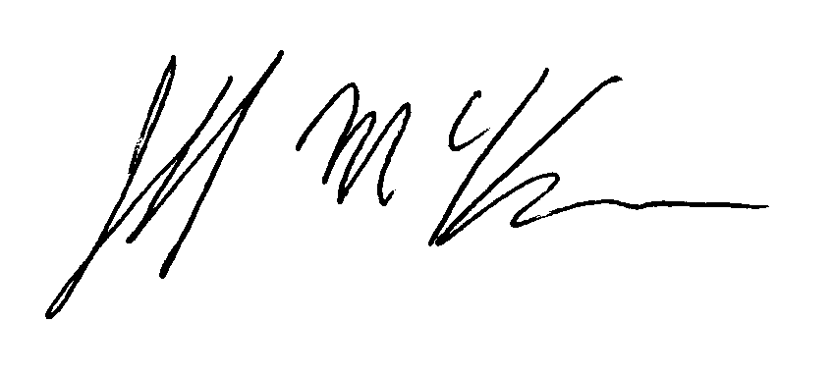

--
Jeff McKenna
President, Open Source Geospatial Foundation
1101 Blue Rocks Road
Lunenburg, NS, Canada
B0J 2C0
+1.902.529.1238



