MapServer with OSGeo4W Users Guide

Last updated: 2010-11-16


About the MapServer with OSGeo4W Users Guide

The “MapServer with OSGeo4W Users Guide” was developed through funding from the Japan Science and Technology Agency, through Japanese project partners Osaka City University, Tezukayamagakuin University, and Applied Technology Co., as well as Gateway Geomatics in Canada.
The users guide has been adapted from the “MapServer Users Guide” originally created in 2004 by Osaka City University and Orkney Inc. of Japan.

The spatial data used in this guide is provided courtesy of Orkney Inc. of Japan. Copyright of the data belongs to Orkney, Inc of Japan.

Table of Contents
Background Technical Information 4
Installing MapServer with OSGeo4W 5
Using MapServer CGI to Create an Application 10
Install the “MapServer Tutorial” OSGeo4W Package 10
Exercise 1: Display a Layer 13
Exercise 2: Change Style Attributes 17
Exercise 3: Using Attribute Filters 20
Exercise 4: Adding More Layers 23
Exercise 5: Adding Labels 27
Exercise 6: Using Templates to Add Navigation Controls 33
Exercise 7: Using Scale Ranges 41
Exercise 8: Adding a Scale Bar 46
Exercise 9: Adding a Legend 54
Exercise 10: Adding Layer Controls 63
Exercise 11: Adding Layer Queries 72
Using WMS Services with MapServer 83
About WMS 83
Exercise 12: Serving WMS Layers Through MapServer (WMS Server) 83
Exercise 13: Consuming Remote WMS Layers in MapServer (WMS Client) 95
Using OpenLayers with Your MapServer Data 102
About OpenLayers 102
Exercise 14: Creating a Simple OpenLayers Viewer 102
Using Quantum GIS with MapServer 106
About Quantum GIS 106
Exercise 15: Add a WMS Layer in QGIS and Export to MapServer 106
Using WFS Services with MapServer 114
About WFS 114
Exercise 16: Serving WFS Layers Through MapServer (WFS Server) 114
Exercise 17: Consuming Remote WFS Layers in MapServer (WFS Client) 121
Using WCS Services with MapServer 127
About WCS 127
Exercise 18: Serving WCS Layers Through MapServer 127

Background Technical Information

This user guide refers to the use of MapServer (http://www.mapserver.org/), which is Open Source software that is used to publish and share your spatial information through the Internet. MapServer contains many excellent documents that you should be familiar with, including:
- Introduction to MapServer: http://www.mapserver.org/introduction.html
- Mapfile Reference: http://www.mapserver.org/mapfile/
- Data Input in MapServer: http://www.mapserver.org/input/
- OGC Support in MapServer: http://www.mapserver.org/ogc/

This user guide is based on MapServer version 5.6.5.

Installing MapServer with OSGeo4W

OSGeo4W (http://trac.osgeo.org/osgeo4w/) is an installer for the Windows operating system that contains many useful software packages related to the Open Source Geospatial Foundation (http://www.osgeo.org/).

Step 1: Download OSGeo4W

Download the OSGeo4W installer from: http://download.osgeo.org/osgeo4w/osgeo4w-setup.exe
Save the file onto your desktop.

Step 2: Start the OSGeo4W Installer

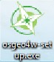
Double-click the 'osgeo4w-setup.exe' file. You should see the following opening window of OSGeo4W:

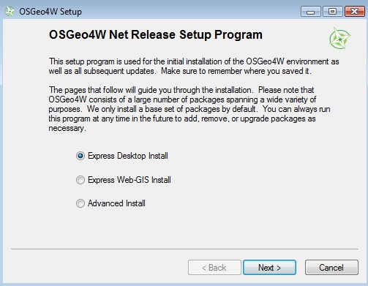

Step 3: Select 'Express Web-GIS Install' Option

Click on the 'Express Web-GIS Install' option, and click on the 'Next' button.

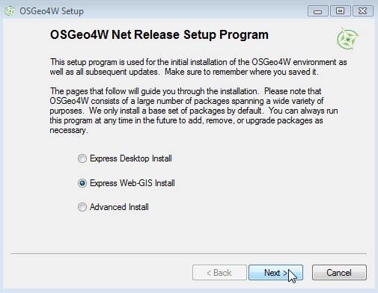

Step 4: Select Packages to Install
Since we are installing MapServer and its dependent libraries, we can leave all of the packages selected (MapServer, GDAL, Apache) and click on the next button. You can optionally specify the Apache port number to use, although leaving the port as 80 is recommended. Click the “Next” button to begin installation.
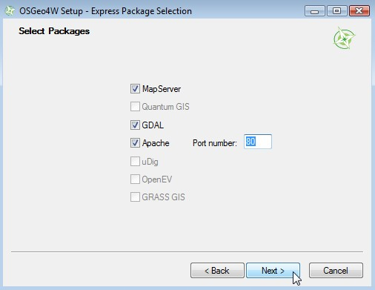
Step 5: Download Packages
The installer should now automatically fetch and install MapServer and all of its libraries from the OSGeo download server.

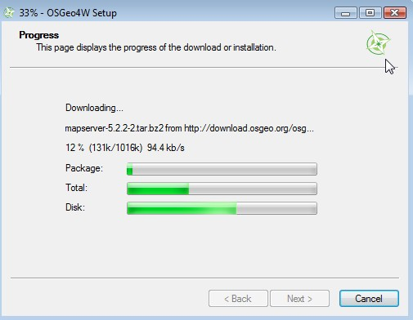

Step 6: Finish Installation
Once downloading and installation from the OSGeo download server is complete, you can now optionally choose to create shortcuts for OSGeo4W on your desktop, and also in your Start Menu (both are recommended). Click the “Finish” button to finalize the installation.

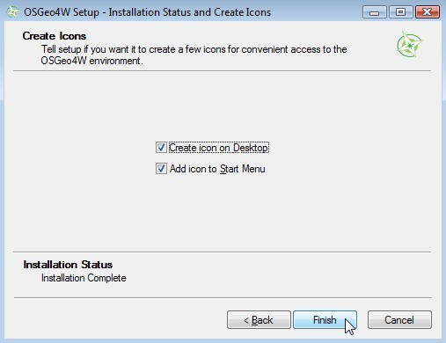
Step 7: Verify your MapServer Installation
You can verify that MapServer is installed through several ways.
- click on the OSGeo4W shortcut on your desktop – a command window should be opened (note: Vista and Windows7 users should first right-click on the OSGeo4W shortcut and select “Run as Administrator”)
- type the following in the command window: mapserv -v
- the MapServer version should be returned, such as:
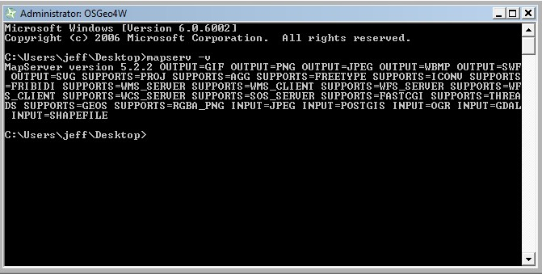
- Verify that Apache was installed properly by opening a Web browser, such as Internet Explorer or Firefox, and going to the location http://localhost/ You should see an OSGeo4W page such as:
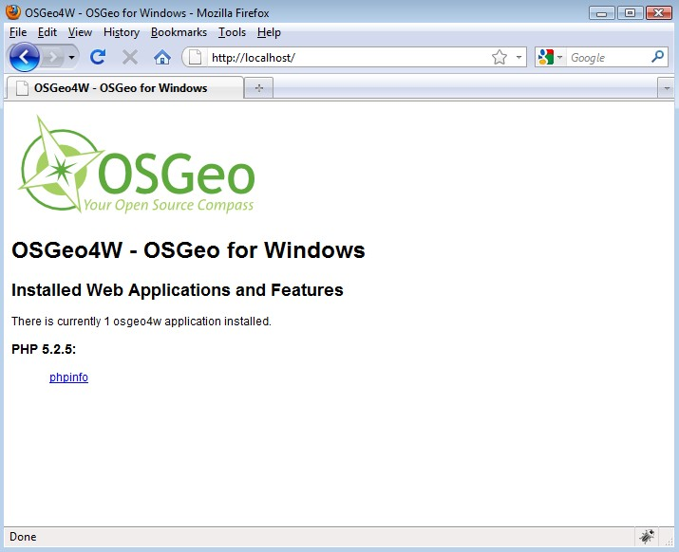
- If you do not see the OSGeo4W opening page in your Web browser:
- right-click on the OSGeo4W desktop shortcut and select “Run as Administrator”
- type the following in the command window: apache-install.bat
- you should see a message that Apache was installed and started successfully, such as:
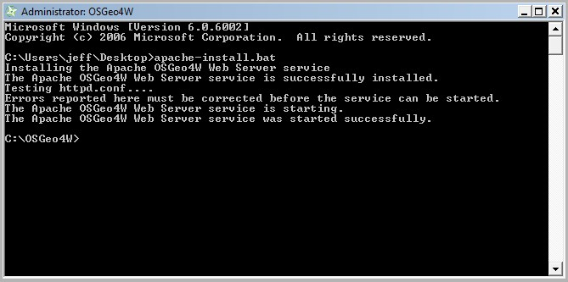
- now re-try http://localhost/ in your Web browser

Using MapServer CGI to Create an Application
The following section is based on the “MapServer Tutorial” package for OSGeo4W. Execute the following to install the package, which includes data and all application files.

Install the “MapServer Tutorial” OSGeo4W Package
- Start the 'osgeo4w-setup.exe' installer and select the “Advanced Install” option.
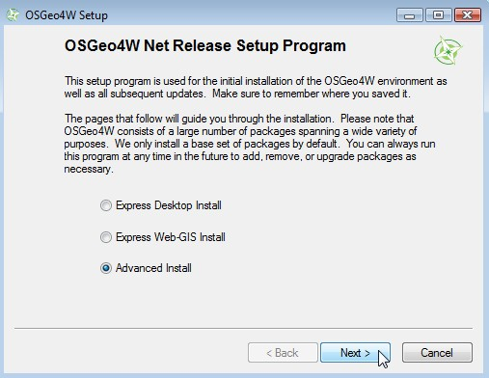
- Advance to the “Select Packages” window.
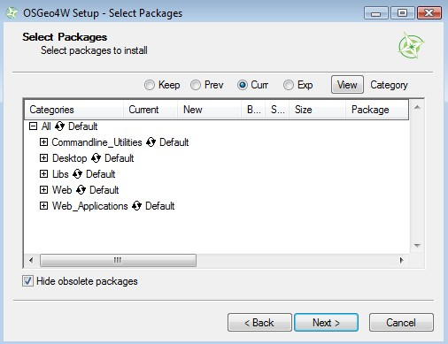

- Expand the “Web_Applications” tree.
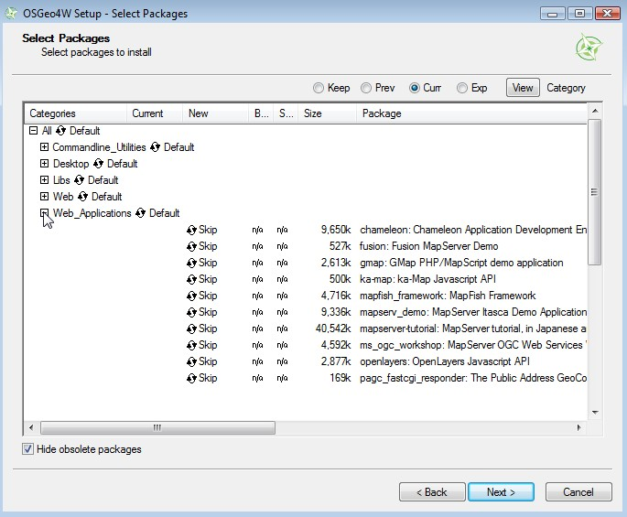
- Install the “mapserver-tutorial” package. Cick on the “skip” beside the “mapserver-tutorial” text, so that a version number is listed, and then click <Next>.
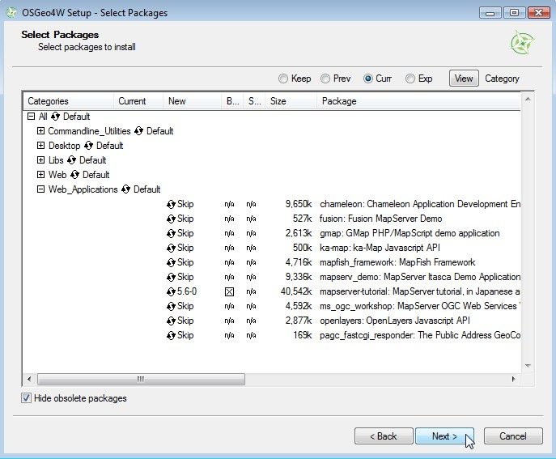
- The tutorial files will automatically download from the OSGeo download server.
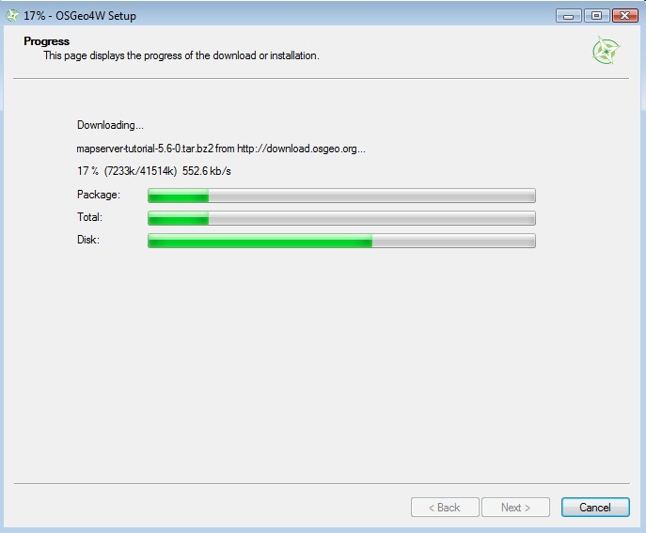
- Open your Web browser (such as Internet Explorer or Firefox) and goto http://localhost/ - you should now see a section on the page containing the MapServer Tutorial.
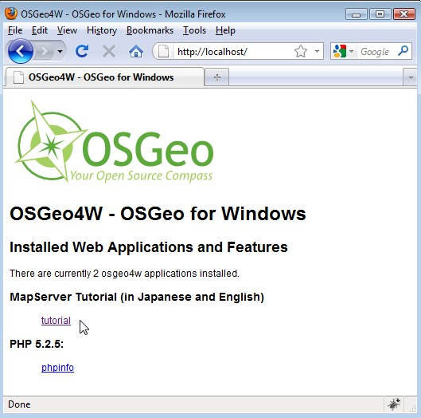

- Goto the MapServer tutorial by clicking on the “tutorial” link. The opening page for the tutorial should be displayed.

Exercise 1: Display a Layer
This example consists of a single map layer. MapServer stores data configuration parameters in a .map file. More information about mapfiles can be found at: http://www.mapserver.org/mapfile/
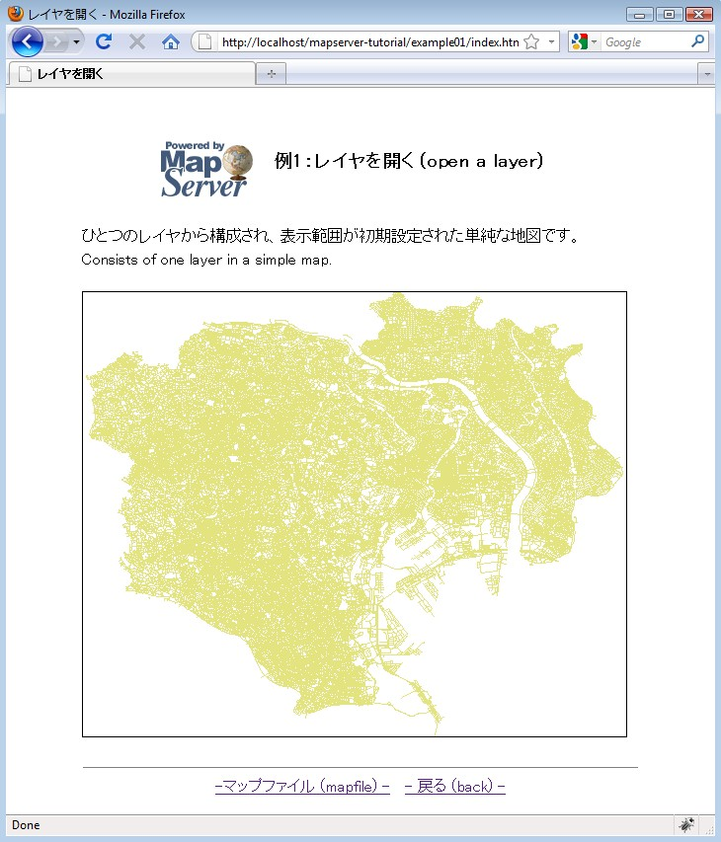

The mapfile used in this exercise is:

MAP
IMAGETYPE PNG
EXTENT 139.562947 35.524705 139.917821 35.817635
SIZE 550 450

IMAGECOLOR 255 255 255
SHAPEPATH "../data"

# Start of LAYER DEFINITIONS-------------------------------
LAYER
NAME "“¹˜H"
DATA dourokukan
STATUS DEFAULT
TYPE LINE

CLASS
NAME "“¹˜H"
STYLE
COLOR 227 227 127
END
END
END
# End of LAYER DEFINITIONS -------------------------------
END

The MapServer mapfile is based on objects. Each object contains parameters or other objects. All valid objects and parameters are documented at: http://www.mapserver.org/mapfile/. The mapfile has a hierarchical structure; the MAP object is always the top-level object, and all other objects exist within the MAP object (see the following image). Each object has an “END” parameter, that signals the closing of the object. Comments in a mapfile are lines that begin with the “#” character.

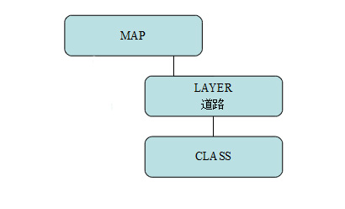

MAP
This is the top-level object, and is required for every mapfile.

IMAGETYPE
The imagetype parameter is used to specify the output format of the map image.

EXTENT
The extent parameter specifies the output range of the map. A useful tool to retrieve extents of a file is the commandline ogrinfo.exe tool, which you can use through the OSGeo4W shell shortcut on your desktop.

SIZE
The size values are the size in pixels of the output map image.

IMAGECOLOR
This is the color of the background of the map, in RGB format.

SHAPEPATH
This is the path to the folder containing the spatial data. You can use absolute paths (full paths) to the data directory, or relative paths to the data directory (relative to the mapfile).

LAYER
This marks the start of a LAYER object. Since MapServer version 5.0, there is no limit to the number of layers you can have in a mapfile.

NAME
A string identifier for the layer.

DATA
The data filename, relative to the SHAPEPATH. If you do not specify an extension, MapServer will assume “.shp”. More information on the many types of data that MapServer can read directly can be found at: http://www.mapserver.org/input/

STATUS
Tells MapServer to show the layer or not. Valid values are ON/OFF/DEFAULT. DEFAULT is required for MapServer CGI (if you are calling mapserv.exe).

TYPE
The geometry type of the data. Common types are POINT/LINE/POLYGON for vector data, and also RASTER for raster data. Consult the mapfile reference for all valid types.

CLASS
This marks the start of a CLASS object. CLASS objects are used with STYLE objects to classify the data.

NAME
It is good practice to always provide a name for each your CLASS objects.

STYLE
This marks the start of a STYLE object. The STYLE object contains colors needed for your layer. A single CLASS object can have several STYLE objects.

COLOR
This is a color in RGB format.

Exercise 2: Change Style Attributes
This example consists of a single map layer classified by two attribute values.

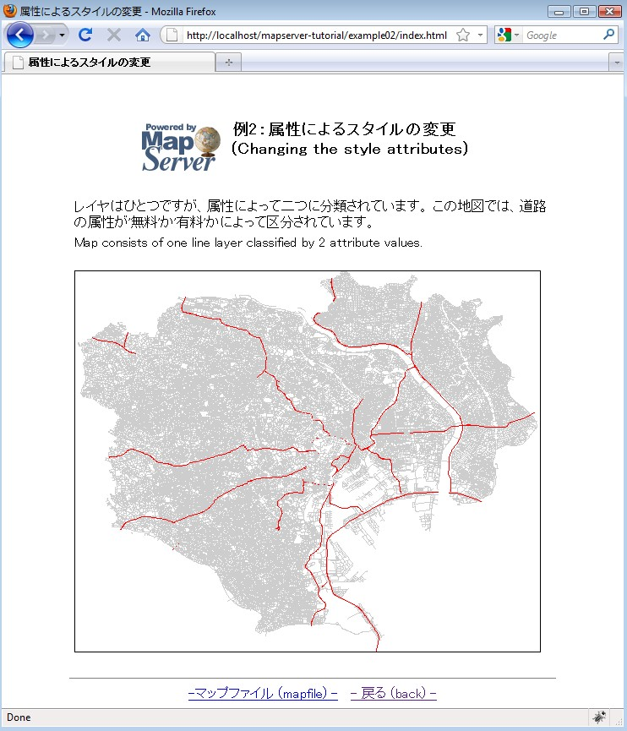

The mapfile used in this exercise is:

MAP
IMAGETYPE PNG
EXTENT 139.562947 35.524705 139.917821 35.817635
SIZE 550 450
IMAGECOLOR 255 255 255
SHAPEPATH "../data"
LAYER
NAME "“¹˜H"
DATA dourokukan
STATUS DEFAULT
TYPE LINE
CLASSITEM "YURYO"
CLASS
NAME "first class"
EXPRESSION '–³—¿'
STYLE
COLOR 205 205 205
END
END
CLASS
NAME "second class"
EXPRESSION '—L—¿'
STYLE
COLOR 255 0 0
END
END
END
END

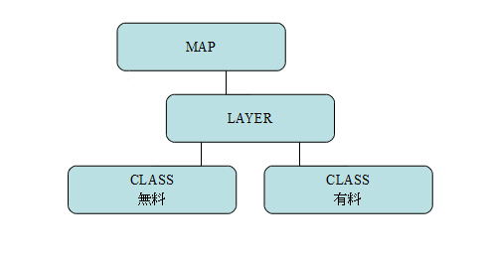
As you can see in the mapfile, the line layer now contains two CLASS objects, used to style the two attributes. This mapfile contains a couple of important parameters:

CLASSITEM
The attribute field used to classify the layer. In this example, the attribute "YURYO" is used; if you open dourokukan.dbf you will see that the field exists there.

EXPRESSION
The value to use for each class. More information about MapServer expressions can be found at: http://www.mapserver.org/mapfile/expressions.html

Exercise 3: Using Attribute Filters
This example consists of a single map layer using an attribute filter.
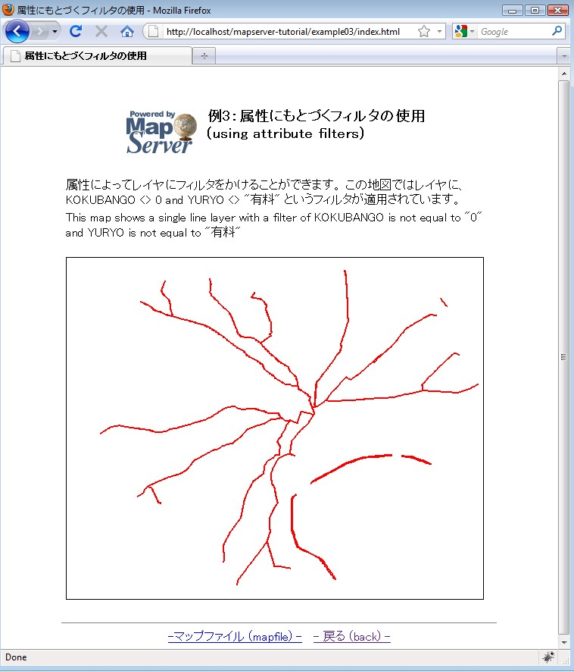

The mapfile used in this exercise is:

MAP
IMAGETYPE PNG
EXTENT 139.562947 35.524705 139.917821 35.817635
SIZE 550 450
IMAGECOLOR 255 255 255
SHAPEPATH "../data"

LAYER
NAME "“¹˜H"
DATA dourokukan
STATUS DEFAULT
TYPE LINE
FILTER ("[KOKUBANGO]" ne "0" and "[YURYO]" ne "—L—¿" )
CLASS
NAME "“¹˜H"
STYLE
COLOR 250 0 0
WIDTH 2
END
END
END

END

This mapfile contains a FILTER parameter within the LAYER object.
FILTER is used to perform data filtering (before evaluating a CLASS's EXPRESSION). In this case, the filter executed is for when the KOKUBANGO field is not equal to 0, and the YURYO field is not equal to “—L—¿”.

Exercise 4: Adding More Layers
This example consists of a map containing many layers.
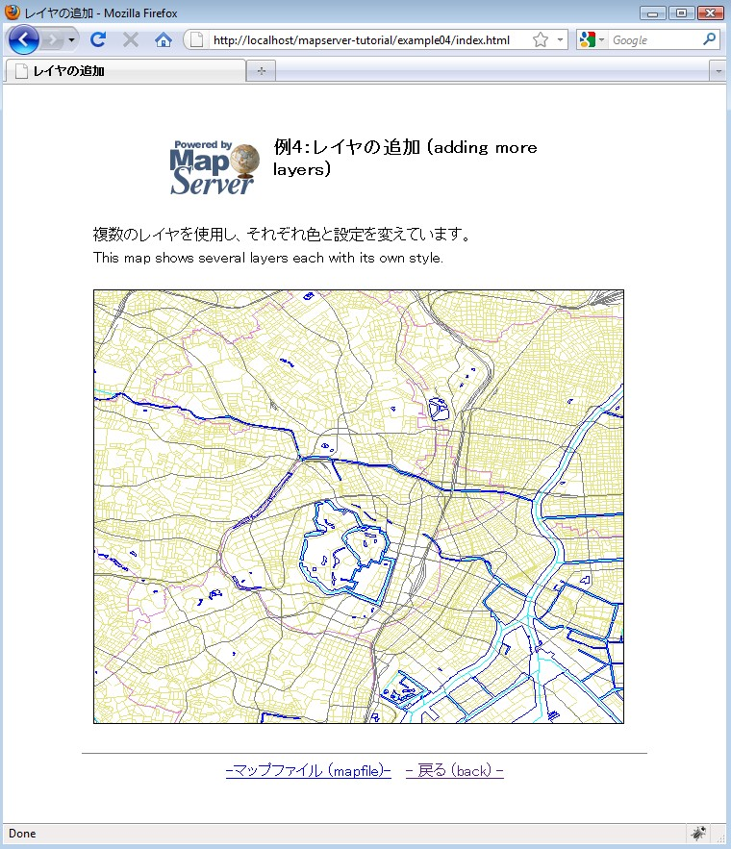

The mapfile used in this exercise is:

MAP
IMAGETYPE PNG
EXTENT 139.70668 35.66589 139.80472 35.72194
SIZE 550 450
IMAGECOLOR 255 255 255
SHAPEPATH "../data"
LAYER
NAME "“¹˜H"
DATA dourokukan
STATUS DEFAULT
TYPE LINE
CLASS
NAME "“¹˜H"
STYLE
COLOR 227 227 127
END
END
END
LAYER
NAME "s"
DATA gyouseikai
STATUS DEFAULT
TYPE LINE
CLASS
NAME "s"
STYLE
COLOR 227 127 227
END
END
END
LAYER
NAME "“S“¹"
DATA tetsudokukan

STATUS DEFAULT
TYPE LINE
CLASS
NAME "“S“¹"
STYLE
COLOR 128 128 128
END
END
END
LAYER
NAME "‰Íì"
DATA kasenkukan
STATUS DEFAULT
TYPE LINE
CLASS
NAME "‰Íì"
STYLE
COLOR 0 255 255
END
END
END
LAYER
NAME "…ˆæ"
DATA suiikikai
STATUS DEFAULT
TYPE LINE
CLASS
NAME "…ˆæ"
STYLE
COLOR 0 0 255
END
END
END
END

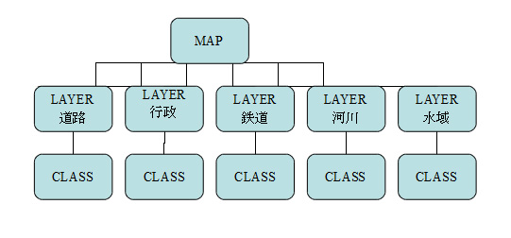
This mapfile example contains 5 LAYERs, each with its own CLASS object. It is important to note that MapServer draws the layers as it reads the .map file, from top to bottom. This means that a layer at the end of the mapfile will appear on top of all of the other layers in the output image.

Exercise 5: Adding Labels
This example shows how to add labels to a layer.
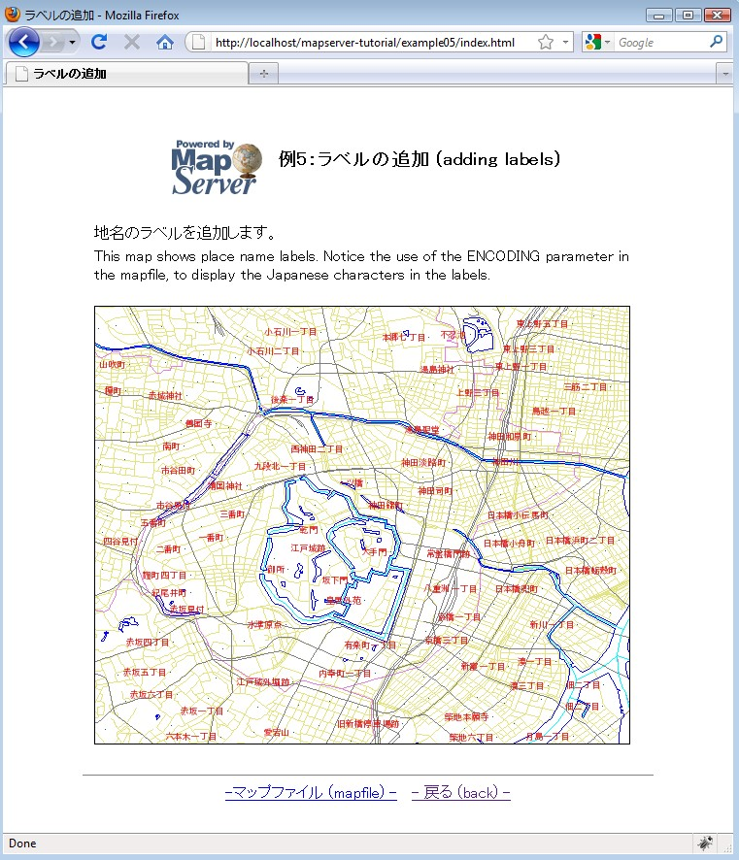

The mapfile used in this exercise is:

MAP
IMAGETYPE PNG
EXTENT 139.72520 35.67139 139.78845 35.70731
SIZE 550 450
IMAGECOLOR 255 255 255
SHAPEPATH "../data"
FONTSET ../fonts/fonts.txt
LAYER
NAME "“¹˜H"
DATA dourokukan
STATUS DEFAULT
TYPE LINE
CLASS
NAME "“¹˜H"
STYLE
COLOR 227 227 127
END
END
END
LAYER
NAME "s"
DATA gyouseikai
STATUS DEFAULT
TYPE LINE
CLASS
NAME "s"
STYLE
COLOR 227 127 227
END
END
END
LAYER
NAME "“S“¹"

DATA tetsudokukan
STATUS DEFAULT
TYPE LINE
CLASS
NAME "“S“¹"
STYLE
COLOR 128 128 128
END
END
END
LAYER
NAME "‰Íì"
DATA kasenkukan
STATUS DEFAULT
TYPE LINE
CLASS
NAME "‰Íì"
STYLE
COLOR 0 255 255
END
END
END
LAYER
NAME "…ˆæ"
DATA suiikikai
STATUS DEFAULT
TYPE LINE
CLASS
NAME "…ˆæ"
STYLE
COLOR 0 0 255
END
END
END

LAYER
NAME "’n–¼"
DATA chimei
STATUS DEFAULT
TYPE POINT
LABELITEM "NAMAE"
CLASS
NAME "’n–¼"
STYLE
COLOR 10 100 100
END
LABEL
TYPE TRUETYPE
FONT pgothic
COLOR 220 20 20
SIZE 7
POSITION CL
PARTIALS FALSE
BUFFER 3
ENCODING "SHIFT_JIS"
END
END
END
END

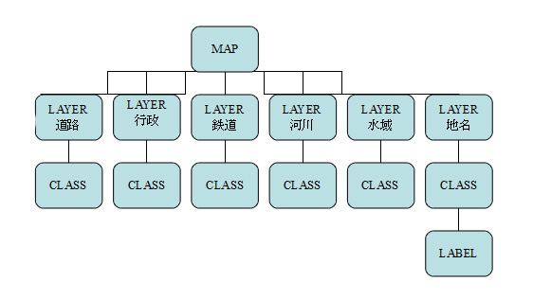
This mapfile contains several layers, with one point layer that uses a LABEL object to show place names. The mapfile used in this example contains several important parameters:

FONTSET
Specify the full path to the font list file. This file defines the available fonts and their aliases. In this case the FONTSET file contains the following (alias, followed by filename):

gothic ipag.ttf
pgothic ipagp.ttf
uigothic ipagui.ttf
mincho ipam.ttf
pmincho ipamp.ttf
LABELITEM
Specifies the field to be used for the label values; in this example, the field "NAMAE" contains the label values.
LABEL
Indicates the beginning of the LABEL object.
TYPE
Specify the font type to use. MapServer accepts both BITMAP or TRUETYPE here, but TrueType fonts are scalable through MapServer and are recommended.
FONT
Specify the font to be used. The value specified here is the alias used for the font in the FONTSET.
COLOR
Specify the label text color.
SIZE
If you use TrueType fonts, this is the size of the font specified in pixels. If you use Bitmap fonts, you can specify “tiny”, “small”, “medium”, “large”, or “giant”.
POSITION
The position of point labels. In this example, “CL” is used to specify center&left of the point.
PARTIALS
Specifies whether to include labels that are cut off by the edge of the map. By default, an incomplete label will not be shown. In this example, FALSE means to not show incomplete labels.
BUFFER
The padding of the label in pixels.
ENCODING
The encoding type to use for the label characters. More information about displaying international characters in MapServer can be found at: http://www.mapserver.org/mapfile/labelencoding.html

Exercise 6: Using Templates to Add Navigation Controls
This example shows how use HTML templates to add such tools as navigation to the map interface.
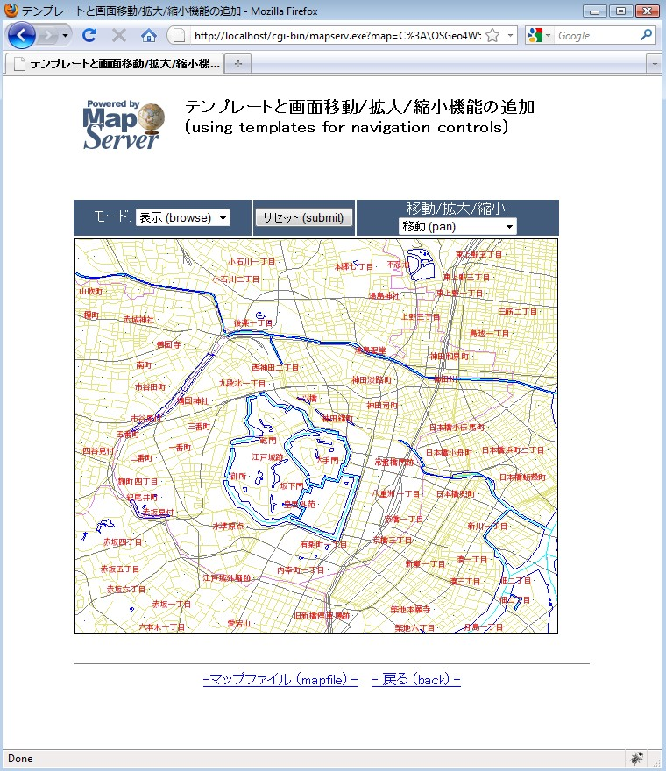

The various tools located above the map image (such as zoom-in or zoom-out) are controlled through an HTML template. The template used in this example follows:

<!-- MapServer Template -->
<html>
<head>
<meta http-equiv="Content-Type" content="text/html; charset=Shift_JIS">
<title>ƒeƒ“ƒvƒŒ[ƒg‚Æ‰æ–ÊˆÚ“®/Šg‘å/k¬‹@”\‚Ì’Ç‰Á</title>
</head>
<body BGCOLOR="white" TEXT="#000000" LINK="#0000FF" VLINK="#0000FF">
<table width="601" align="center" border="0">
<tr>
<td width="593" align=center>
<table cellpadding=10 >
<tr>
<td align=left><img src="/mapserver-tutorial/img/powered_mapserver.jpg"></td>
<td align=left><h3>ƒeƒ“ƒvƒŒ[ƒg‚Æ‰æ–ÊˆÚ“®/Šg‘å/k¬‹@”\‚Ì’Ç‰Á (using templates for navigation controls)</h3></td>
</tr>
</table>
<br>
<!-- START OF MAPSERVER FORM -->
<form name="mapserv" method="GET" action="/cgi-bin/mapserv.exe">
<!-- HIDDEN MAPSERVER CGI VARIABLES -->
<input type="hidden" name="map" value="[map]">
<input type="hidden" name="imgext" value="[mapext]">
<tr>
<td>
<table width="400" border="0">
<tr>
<td bgcolor="#425b7a" width="40%" >
<!-- SPECIFY MAP MODE -->
<div align="center"><font color=white>ƒ‚[ƒh: </font>
<select name="mode">
<option value="browse">•\Ž¦ (browse)</option>
<option value="map">’n} (map)</option>

</select>
</div>
</td>
<td bgcolor="#425b7a" width="15%">
<!-- FORM SUBMIT BUTTON -->
<div align="center">
<input type="submit" name="submit" value="ƒŠƒZƒbƒg (submit)">
</div>
</td>
<td bgcolor="#425b7a" width="45%">
<!-- ZOOM/PAN CONTROLS -->
<div align="center"><font color=white>ˆÚ“®/Šg‘å/k¬:</font>
<select name="zoom">
<option value="4" [zoom_4_select]>Šg‘å 4x (zoom-in)</option>
<option value="3" [zoom_3_select]>Šg‘å 3x (zoom-in)</option>
<option value="2" [zoom_2_select]>Šg‘å 2x (zoom-in)</option>
<option value="1" [zoom_1_select]>ˆÚ“® (pan)</option>
<option value="-2" [zoom_-2_select]>k¬ 2x (zoom-out)</option>
<option value="-3" [zoom_-3_select]>k¬ 3x (zoom-out)</option>
<option value="-4" [zoom_-4_select]>k¬ 4x (zoom-out)</option>
</select>
</div>
</td>
</tr>
<tr>
<!-- DISPLAY THE MAPSERVER-CREATED MAP IMAGE -->
<td colspan="3" align="right" valign="top">
<input type="image" name="img" src="[img]"
width="550" height="450" border="1">
</td>
</tr>
</table>
</td>
</tr>
</form>

</table>
<br>
<hr noshade width="80%" size="1" align="center">
<center>
<a href="/mapserver-tutorial/example06/example_map.html">-ƒ}ƒbƒvƒtƒ@ƒCƒ‹ (mapfile) -</a>&nbsp;&nbsp;
<a href="/mapserver-tutorial/index.html">- –ß‚é (back) -</a>
</center>
</body>
</html>

The HTML template above contains several MapServer CGI controls; all of the valid MapServer controls are documented at: http://www.mapserver.org/cgi/controls.html
The following are the important points regarding the example template:

<!-- MapServer Template -->
Often referred to as the “MapServer magic string”, this string is required at the beginning of every MapServer template file. This is required since MapServer version 5.2.2

Items in square brackets ([map], [mapext], [img], [zoom_n_select]) are used by MapServer; MapServer will replace these with values during run-time.

[Map]
During run-time, this is replaced with the full path to the mapfile (such as “/OSGeo4W/apps/mapserver-tutorial/example06/example.map”).
[Mapext]
During run-time, this is replaced with the current extents of the map image (such as “139.725200 35.663485 139.788450 35.715215”).
[Img]
During run-time, this is replaced with the path to the generated map image (such as “/ms_tmp/MS12821491423356.png”).
MODE
“Mode” used in the template is “browse”, which tells MapServer that a fully interactive map will be generated, or “map” which tells MapServer just to return a static map image to the browser.
[Zoom_n_select]
Represents a zoom of a specified value. Negative values here tell MapServer to zoom out.

The mapfile used in this exercise is:

MAP
IMAGETYPE PNG
EXTENT 139.72520 35.67139 139.78845 35.70731
SIZE 550 450
IMAGECOLOR 255 255 255
SHAPEPATH "../data"
FONTSET ../fonts/fonts.txt
WEB
TEMPLATE 'example_template.html'
IMAGEPATH "C:/OSGeo4W/tmp/ms_tmp/"
IMAGEURL "/ms_tmp/"
END
LAYER
NAME "“¹˜H"
DATA dourokukan
STATUS DEFAULT
TYPE LINE
CLASS
NAME "“¹˜H"
STYLE
COLOR 227 227 127
END
END
END
LAYER
NAME "s"
DATA gyouseikai
STATUS DEFAULT
TYPE LINE
CLASS
NAME "s"

STYLE
COLOR 227 127 227
END
END
END
LAYER
NAME "“S“¹"
DATA tetsudokukan
STATUS DEFAULT
TYPE LINE
CLASS
NAME "“S“¹"
STYLE
COLOR 128 128 128
END
END
END
LAYER
NAME "‰Íì"
DATA kasenkukan
STATUS DEFAULT
TYPE LINE
CLASS
NAME "‰Íì"
STYLE
COLOR 0 255 255
END
END
END
LAYER
NAME "…ˆæ"
DATA suiikikai
STATUS DEFAULT
TYPE LINE

CLASS
NAME "…ˆæ"
STYLE
COLOR 0 0 255
END
END
END
LAYER
NAME "’n–¼"
DATA chimei
STATUS DEFAULT
TYPE POINT
LABELITEM "NAMAE"
CLASS
NAME "’n–¼"
STYLE
COLOR 10 100 100
END
LABEL
TYPE TRUETYPE
FONT pgothic
COLOR 220 20 20
SIZE 7
POSITION CL
PARTIALS FALSE
BUFFER 3
ENCODING "SHIFT_JIS"
END
END
END
END

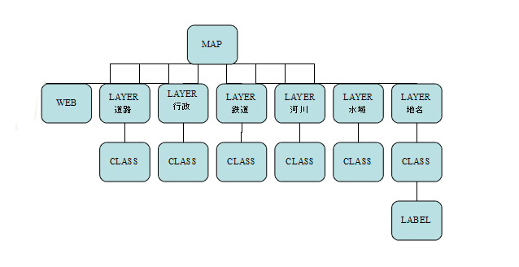
The mapfile in this example includes a WEB object, and its parameters are described below:

TEMPLATE
The file to use as a template file, relative to the mapfile location. MapServer will replace the controls included in this file with proper values during run-time.
IMAGEPATH
The directory to store the generated map images.
IMAGEURL
The URL to the directory where the generated map images are stored. In this example, OSGeo4W's Apache server is configured for the “ms_tmp” URL.

Exercise 7: Using Scale Ranges
This example shows how use scale ranges at both the MAP level and at the LAYER level in a mapfile.
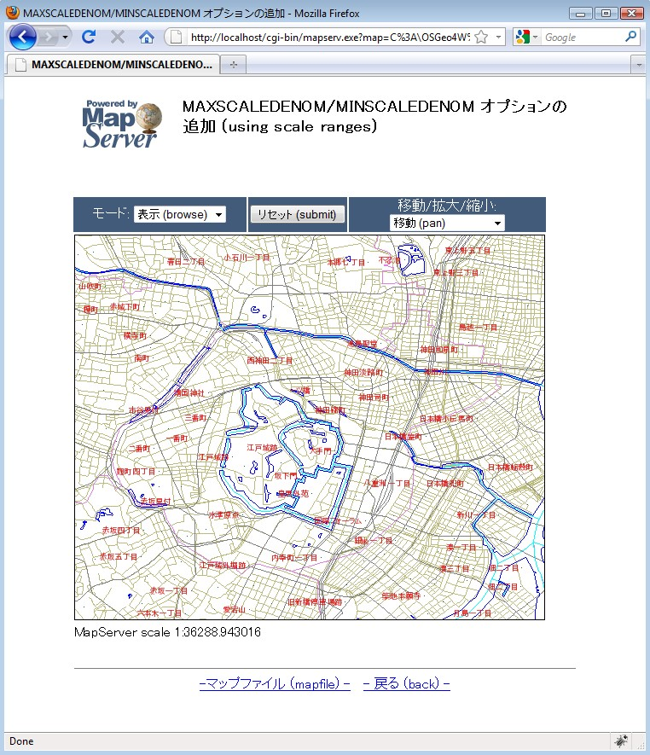
The mapfile used in this exercise is:

MAP
IMAGETYPE PNG
EXTENT 139.72520 35.67139 139.78845 35.70731
SIZE 550 450
IMAGECOLOR 255 255 255
SHAPEPATH "../data"
FONTSET ../fonts/fonts.txt
UNITS dd
WEB
TEMPLATE 'example_template.html'
IMAGEPATH "C:/OSGeo4W/tmp/ms_tmp/"
IMAGEURL "/ms_tmp/"
MINSCALEDENOM 1000
MAXSCALEDENOM 70000
END
LAYER
NAME "“¹˜H"
DATA dourokukan
STATUS DEFAULT
TYPE LINE
MAXSCALEDENOM 50000
CLASS
NAME "“¹˜H"
STYLE
COLOR 187 187 127
END
END
END
LAYER
NAME "s"
DATA gyouseikai
STATUS DEFAULT
TYPE LINE

CLASS
NAME "s"
STYLE
COLOR 227 127 227
END
END
END
LAYER
NAME "“S“¹"
DATA tetsudokukan
STATUS DEFAULT
TYPE LINE
CLASS
NAME "“S“¹"
STYLE
COLOR 128 128 128
END
END
END
LAYER
NAME "‰Íì"
DATA kasenkukan
STATUS DEFAULT
TYPE LINE

CLASS
NAME "‰Íì"
STYLE
COLOR 0 255 255
END
END
END
LAYER
NAME "…ˆæ"

DATA suiikikai
STATUS DEFAULT
TYPE LINE
CLASS
NAME "…ˆæ"
STYLE
COLOR 0 0 255
END
END
END
LAYER
NAME "’n–¼"
DATA chimei
STATUS DEFAULT
TYPE POINT
LABELITEM "NAMAE"
CLASS
NAME "’n–¼"
STYLE
COLOR 10 100 100
END
LABEL
TYPE TRUETYPE
FONT pgothic
COLOR 220 20 20
SIZE 7
POSITION CL
PARTIALS FALSE
BUFFER 5
ENCODING "SHIFT_JIS"
END
END
END
END
As you can see in this mapfile example, the parameters MINSCALEDENOM and MAXSCALEDENOM can be used to specify scale ranges in a mapfile.

MINSCALEDENOM
The minimum scale at which to draw this layer. In this example, a MINSCALEDENOM is set in the WEB object, with a value of 1,000 – which means that users will not be able to zoom in past a scale of 1,000.

MAXSCALEDENOM
The maximum scale at which to draw this layer. In this example, a MAXSCALEDENOM is set in the WEB object, with a value of 70,000 – which means that users will not be able to zoom outpast a scale of 70,000. A MAXSCALEDENOM of 50,000 is also set in this example in the dourokukan layer – which means that this layer will not be displayed past a scale of 50,000.

Exercise 8: Adding a Scale Bar
This example shows how to add a scale bar through the use of an HTML template.
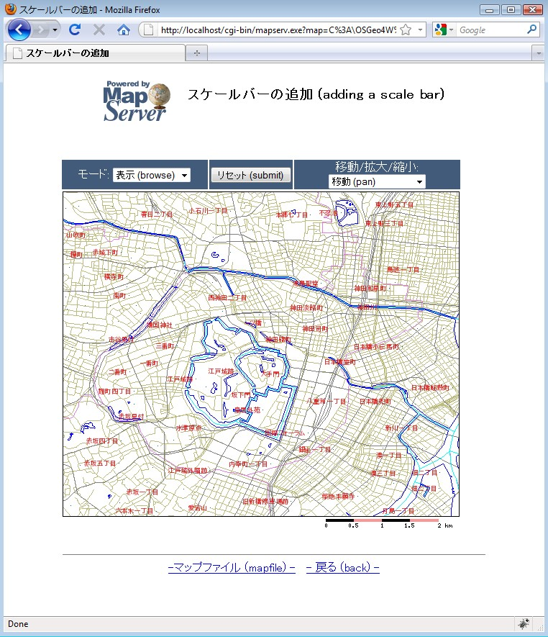
The mapfile used in this exercise is:

MAP
IMAGETYPE PNG
EXTENT 139.72520 35.67139 139.78845 35.70731
SIZE 550 450
IMAGECOLOR 255 255 255
SHAPEPATH "../data"
FONTSET ../fonts/fonts.txt
UNITS dd
WEB
TEMPLATE 'example_template.html'
IMAGEPATH "C:/OSGeo4W/tmp/ms_tmp/"
IMAGEURL "/ms_tmp/"
MINSCALEDENOM 1000
MAXSCALEDENOM 70000
END
SCALEBAR
UNITS kilometers
BACKGROUNDCOLOR 250 150 150
COLOR 0 0 0
TRANSPARENT on
STYLE 0
STATUS on
LABEL
COLOR 0 0 0
SIZE tiny
END
END
LAYER
NAME "“¹˜H"
DATA dourokukan
STATUS DEFAULT
TYPE LINE
MAXSCALEDENOM 50000

CLASS
NAME "“¹˜H"
STYLE
COLOR 187 187 127
END
END
END
LAYER
NAME "s"
DATA gyouseikai
STATUS DEFAULT
TYPE LINE

CLASS
NAME "s"
STYLE
COLOR 227 127 227
END
END
END
LAYER
NAME "“S“¹"
DATA tetsudokukan
STATUS DEFAULT
TYPE LINE
CLASS
NAME "“S“¹"
STYLE
COLOR 128 128 128
END
END
END
LAYER
NAME "‰Íì"

DATA kasenkukan
STATUS DEFAULT
TYPE LINE
CLASS
NAME "‰Íì"
STYLE
COLOR 0 255 255
END
END
END
LAYER
NAME "…ˆæ"
DATA suiikikai
STATUS DEFAULT
TYPE LINE
CLASS
NAME "…ˆæ"
STYLE
COLOR 0 0 255
END
END
END
LAYER
NAME "’n–¼"
DATA chimei
STATUS DEFAULT
TYPE POINT
LABELITEM "NAMAE"
CLASS
NAME "’n–¼"
STYLE
COLOR 10 100 100
END
LABEL

TYPE TRUETYPE
FONT pgothic
COLOR 220 20 20
SIZE 7
POSITION CL
PARTIALS FALSE
BUFFER 5
ENCODING "SHIFT_JIS"
END
END
END
END

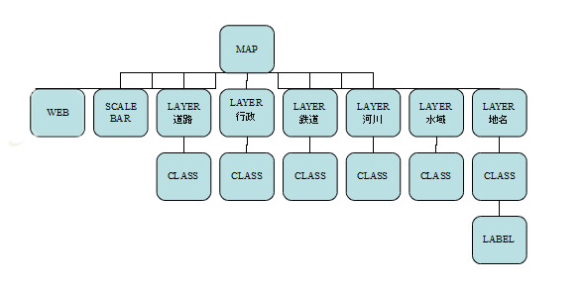
In this example, a SCALEBAR object is added to the mapfile, and its parameters are described next:

SCALEBAR
Marks the start of the SCALEBAR object.
UNITS
Specify the units of scale bar.
BACKGROUNDCOLOR
Color to use for the scalebar background.
COLOR
Color to use for the scalebar bars.
TRANSPARENT
Specifies whether the background color for the scalebar should be transparent.
STYLE
Specifies the style of scale bar.
STATUS
Specifies whether to draw the scale bar.

The template file used in this exercise follows:

<!-- MapServer Template -->
<html>
<head>
<meta http-equiv="Content-Type" content="text/html; charset=Shift_JIS">
<title>ƒXƒP[ƒ‹ƒo[‚Ì’Ç‰Á</title>
</head>
<body BGCOLOR="white" TEXT="#000000" LINK="#0000FF" VLINK="#0000FF">
<table width="601" align="center" border="0">
<tr>
<td width="593" align=center>
<table cellpadding=10 >
<tr>
<td align=left><img src="/mapserver-tutorial/img/powered_mapserver.jpg"></td>
<td align=left><h3>ƒXƒP[ƒ‹ƒo[‚Ì’Ç‰Á (adding a scale bar)</h3></td>
</tr>
</table>
<br>
<!-- START OF MAPSERVER FORM -->
<form name="mapserv" method="GET" action="/cgi-bin/mapserv.exe">
<!-- HIDDEN MAPSERVER CGI VARIABLES -->
<input type="hidden" name="map" value="[map]">
<input type="hidden" name="imgext" value="[mapext]">
<tr>

<td>
<table width="400" border="0">
<tr>
<td bgcolor="#425b7a" width="40%" >
<!-- SPECIFY MAP MODE -->
<div align="center"><font color=white>ƒ‚[ƒh: </font>
<select name="mode">
<option value="browse">•\Ž¦ (browse)</option>
<option value="map">’n} (map)</option>
</select>
</div>
</td>
<td bgcolor="#425b7a" width="15%">
<!-- FORM SUBMIT BUTTON -->
<div align="center">
<input type="submit" name="submit" value="ƒŠƒZƒbƒg (submit)">
</div>
</td>
<td bgcolor="#425b7a" width="45%">
<!-- ZOOM/PAN CONTROLS -->
<div align="center"><font color=white>ˆÚ“®/Šg‘å/k¬:</font>
<select name="zoom">
<option value="4" [zoom_4_select]>Šg‘å 4x (zoom-in)</option>
<option value="3" [zoom_3_select]>Šg‘å 3x (zoom-in)</option>
<option value="2" [zoom_2_select]>Šg‘å 2x (zoom-in)</option>
<option value="1" [zoom_1_select]>ˆÚ“® (pan)</option>
<option value="-2" [zoom_-2_select]>k¬ 2x (zoom-out)</option>
<option value="-3" [zoom_-3_select]>k¬ 3x (zoom-out)</option>
<option value="-4" [zoom_-4_select]>k¬ 4x (zoom-out)</option>
</select>
</div>
</td>
</tr>
<tr>

<!-- DISPLAY THE MAPSERVER-CREATED MAP IMAGE -->
<td colspan="3" align="right" valign="top">
<input type="image" name="img" src="[img]"
width="550" height="450" border="1">
<!-- DISPLAY THE SCALEBAR IMAGE -->
<img src="[scalebar]" border="0">
</td>
</tr>
</table>
</td>
</tr>
</form>
</table>
<br>
<hr noshade width="80%" size="1" align="center">
<center>
<a href="/mapserver-tutorial/example08/example_map.html">-ƒ}ƒbƒvƒtƒ@ƒCƒ‹ (mapfile) -</a>&nbsp;&nbsp;
<a href="/mapserver-tutorial/index.html">- –ß‚é (back) -</a>
</center>
</body>
</html>

The HTML template above contains the [scalebar] control, that is replaced by MapServer during run-time with a scalebar image.

Exercise 9: Adding a Legend
This example shows how to add a legend through the use of an HTML template.
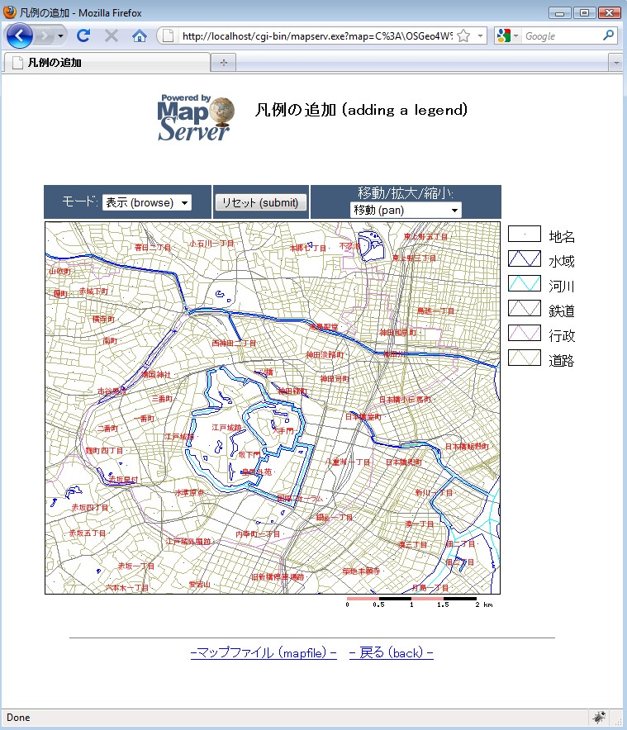

In order to display a legend, the following is required:
- the mapfile must contain a LEGEND object
- each CLASS object in the mapfile must have a NAME parameter
- the HTML template must contain a [legend] control.

The mapfile used in this exercise is:

MAP
IMAGETYPE PNG
EXTENT 139.72520 35.67139 139.78845 35.70731
SIZE 550 450
IMAGECOLOR 255 255 255
SHAPEPATH "../data"
FONTSET ../fonts/fonts.txt
UNITS dd
WEB
TEMPLATE 'example_template.html'
IMAGEPATH "C:/OSGeo4W/tmp/ms_tmp/"
IMAGEURL "/ms_tmp/"
MINSCALEDENOM 1000
MAXSCALEDENOM 70000
END
SCALEBAR
UNITS kilometers
COLOR 250 150 150
BACKGROUNDCOLOR 0 0 0
TRANSPARENT on
STYLE 0
STATUS on
LABEL
COLOR 0 0 0
SIZE tiny
END
END

LEGEND
KEYSIZE 40 20
KEYSPACING 10 10
OUTLINECOLOR 0 0 0
IMAGECOLOR 255 255 255
LABEL
TYPE TRUETYPE
FONT pmincho
COLOR 0 0 0
SIZE 12
POSITION CL
PARTIALS FALSE
BUFFER 3
ENCODING "SHIFT_JIS"
END
STATUS ON
END
LAYER
NAME "“¹˜H"
DATA dourokukan
STATUS DEFAULT
TYPE LINE
MAXSCALEDENOM 50000
CLASS
NAME "“¹˜H"
STYLE
COLOR 187 187 127
END
END
END
LAYER
NAME "s"
DATA gyouseikai
STATUS DEFAULT

TYPE LINE
CLASS
NAME "s"
STYLE
COLOR 227 127 227
END
END
END
LAYER
NAME "“S“¹"
DATA tetsudokukan
STATUS DEFAULT
TYPE LINE
CLASS
NAME "“S“¹"
STYLE
COLOR 128 128 128
END
END
END
LAYER
NAME "‰Íì"
DATA kasenkukan
STATUS DEFAULT
TYPE LINE

CLASS
NAME "‰Íì"
STYLE
COLOR 0 255 255
END
END
END
LAYER

NAME "…ˆæ"
DATA suiikikai
STATUS DEFAULT
TYPE LINE
CLASS
NAME "…ˆæ"
STYLE
COLOR 0 0 255
END
END
END
LAYER
NAME "’n–¼"
DATA chimei
STATUS DEFAULT
TYPE POINT
LABELITEM "NAMAE"
CLASS
NAME "’n–¼"
STYLE
COLOR 10 100 100
END
LABEL
TYPE TRUETYPE
FONT pgothic
COLOR 220 20 20
SIZE 7
POSITION CL
PARTIALS FALSE
BUFFER 5
ENCODING "SHIFT_JIS"
END
END
END
END
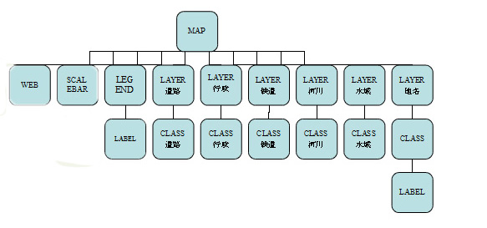
As you can see in the mapfile, a SCALEBAR object is added, and its parameters are described next:

LEGEND
Marks the start of the LEGEND object.
KEYSIZE
Specifies the size in pixels of the key image.
KEYSPACING
Specify the space between the key image and the label, in pixels.
OUTLINECOLOR
Specify the line color of the key image.
IMAGECOLOR
Specifies the background color of the legend.
STATUS
Specifies whether to display the legend.

The template file used in this exercise follows:

<!-- MapServer Template -->
<html>
<head>
<meta http-equiv="Content-Type" content="text/html; charset=Shift_JIS">
<title>–}—á‚Ì’Ç‰Á</title>
</head>
<body BGCOLOR="white" TEXT="#000000" LINK="#0000FF" VLINK="#0000FF">
<table width="601" align="center" border="0">
<tr>
<td width="593" align=center>
<table cellpadding=10 >
<tr>
<td align=left><img src="/mapserver-tutorial/img/powered_mapserver.jpg"></td>
<td align=left><h3>–}—á‚Ì’Ç‰Á (adding a legend)</h3></td>
</tr>
</table>
<br>
<!-- START OF MAPSERVER FORM -->
<form name="mapserv" method="GET" action="/cgi-bin/mapserv.exe">
<!-- HIDDEN MAPSERVER CGI VARIABLES -->
<input type="hidden" name="map" value="[map]">
<input type="hidden" name="imgext" value="[mapext]">
<tr>
<td>
<table width="400" border="0">
<tr>
<td bgcolor="#425b7a" width="40%" >
<!-- SPECIFY MAP MODE -->
<div align="center"><font color=white>ƒ‚[ƒh: </font>
<select name="mode">
<option value="browse">•\Ž¦ (browse)</option>
<option value="map">’n} (map)</option>
</select>
</div>

</td>
<td bgcolor="#425b7a" width="15%">
<!-- FORM SUBMIT BUTTON -->
<div align="center">
<input type="submit" name="submit" value="ƒŠƒZƒbƒg (submit)">
</div>
</td>
<td bgcolor="#425b7a" width="45%">
<!-- ZOOM/PAN CONTROLS -->
<div align="center"><font color=white>ˆÚ“®/Šg‘å/k¬:</font>
<select name="zoom">
<option value="4" [zoom_4_select]>Šg‘å 4x (zoom-in)</option>
<option value="3" [zoom_3_select]>Šg‘å 3x (zoom-in)</option>
<option value="2" [zoom_2_select]>Šg‘å 2x (zoom-in)</option>
<option value="1" [zoom_1_select]>ˆÚ“® (pan)</option>
<option value="-2" [zoom_-2_select]>k¬ 2x (zoom-out)</option>
<option value="-3" [zoom_-3_select]>k¬ 3x (zoom-out)</option>
<option value="-4" [zoom_-4_select]>k¬ 4x (zoom-out)</option>
</select>
</div>
</td>
</tr>
<tr>
<!-- DISPLAY THE MAPSERVER-CREATED MAP IMAGE -->
<td colspan="3" align="right" valign="top">
<input type="image" name="img" src="[img]"
width="550" height="450" border="1">
<!-- DISPLAY THE SCALEBAR IMAGE -->
<img src="[scalebar]" border="0">
</td>
<td valign="top">
<!-- DISPLAY THE LEGEND IMAGE -->
<img src="[legend]">
</td>

</tr>
</table>
</td>
</tr>
</form>
</table>
<br>
<hr noshade width="80%" size="1" align="center">
<center>
<a href="/mapserver-tutorial/example09/example_map.html">-ƒ}ƒbƒvƒtƒ@ƒCƒ‹ (mapfile) -</a>&nbsp;&nbsp;
<a href="/mapserver-tutorial/index.html">- –ß‚é (back) -</a>
</center>
</body>
</html>

The above template includes the [legend] control which MapServer will replace at run-time with a legend image.

Exercise 10: Adding Layer Controls
This example shows how to add the ability to turn layers on and off through the use of an HTML template.
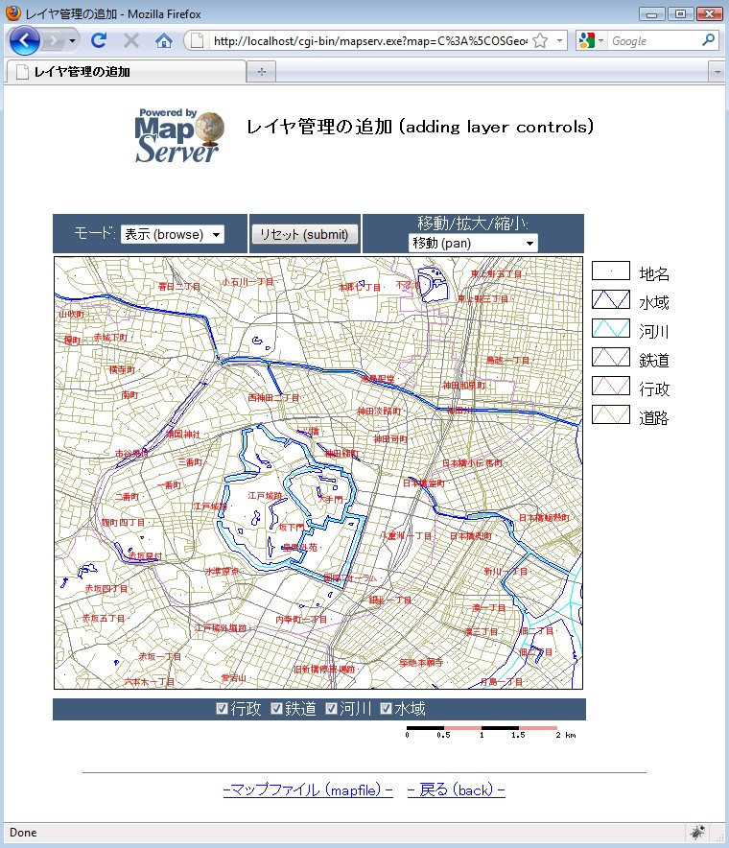

Below the map image you will notice some layer control checkboxes.
To allow the user to turn on/off layers, in the HTML template file you need to add a check box with the name "layer", and the value of each checkbox should be the name of the layer from the mapfile; MapServer will change the layer's STATUS parameter accordingly.

The mapfile used in this exercise is:

MAP
IMAGETYPE PNG
EXTENT 139.72520 35.67139 139.78845 35.70731
SIZE 550 450
IMAGECOLOR 255 255 255
SHAPEPATH "../data"
FONTSET ../fonts/fonts.txt
UNITS dd
WEB
TEMPLATE 'example_template.html'
IMAGEPATH "@osgeo4w@/tmp/ms_tmp/"
IMAGEURL "/ms_tmp/"
MINSCALEDENOM 1000
MAXSCALEDENOM 70000
END
SCALEBAR
UNITS kilometers
BACKGROUNDCOLOR 250 150 150
COLOR 0 0 0
TRANSPARENT on
STYLE 0
STATUS on
LABEL
COLOR 0 0 0
SIZE tiny
END
END
LEGEND
KEYSIZE 40 20

KEYSPACING 10 10
OUTLINECOLOR 0 0 0
IMAGECOLOR 255 255 255
LABEL
TYPE TRUETYPE
FONT pmincho
COLOR 0 0 0
SIZE 12
POSITION CL
PARTIALS FALSE
BUFFER 3
ENCODING "SHIFT_JIS"
END
STATUS ON
END
LAYER
NAME "“¹˜H"
DATA dourokukan
STATUS DEFAULT
TYPE LINE
MAXSCALEDENOM 50000
CLASS
NAME "“¹˜H"
COLOR 187 187 127
END
END
LAYER
NAME "s"
DATA gyouseikai
STATUS ON
TYPE LINE
CLASS
NAME "s"
STYLE

COLOR 227 127 227
END
END
END
LAYER
NAME "“S“¹"
DATA tetsudokukan
STATUS ON
TYPE LINE
CLASS
NAME "“S“¹"
STYLE
COLOR 128 128 128
END
END
END
LAYER
NAME "‰Íì"
DATA kasenkukan
STATUS ON
TYPE LINE
CLASS
NAME "‰Íì"
STYLE
COLOR 0 255 255
END
END
END
LAYER
NAME "…ˆæ"
DATA suiikikai
STATUS ON
TYPE LINE
CLASS

NAME "…ˆæ"
STYLE
COLOR 0 0 255
END
END
END
LAYER
NAME "’n–¼"
DATA chimei
STATUS DEFAULT
TYPE POINT
LABELITEM "NAMAE"
CLASS
NAME "’n–¼"
STYLE
COLOR 10 100 100
END
LABEL
TYPE TRUETYPE
FONT pgothic
COLOR 220 20 20
SIZE 7
POSITION CL
PARTIALS FALSE
BUFFER 5
ENCODING "SHIFT_JIS"
END
END
END
END

Note the STATUS value for each LAYER. Layers with a status of DEFAULT will always be displayed, but the other layers with status ON will be controlled by the HTML template.

The template file used in this exercise follows:

<!-- MapServer Template -->
<html>
<head>
<meta http-equiv="Content-Type" content="text/html; charset=Shift_JIS">
<title>ƒŒƒCƒ„ŠÇ—‚Ì’Ç‰Á</title>
<script type="text/javascript">
function doSubmit()
{
document.mainform.submit();
}
</script>
</head>
<body BGCOLOR="white" TEXT="#000000" LINK="#0000FF" VLINK="#0000FF">
<table width="601" align="center" border="0">
<tr>
<td width="593" align=center>
<table cellpadding=10 >
<tr>
<td align=left><img src="/mapserver-tutorial/img/powered_mapserver.jpg"></td>
<td align=left><h3>ƒŒƒCƒ„ŠÇ—‚Ì’Ç‰Á (adding layer controls)</h3></td>
</tr>
</table>
<br>
<!-- START OF MAPSERVER FORM -->
<form name="mainform" method="GET" action="/cgi-bin/mapserv.exe">
<!-- HIDDEN MAPSERVER CGI VARIABLES -->
<input type="hidden" name="map" value="[map]">
<input type="hidden" name="imgext" value="[mapext]">
<input type="hidden" name="mapext" value="[mapext]">
<tr>
<td>
<table width="400" border="0">
<tr>

<td bgcolor="#425b7a" width="40%" >
<!-- SPECIFY MAP MODE -->
<div align="center"><font color=white>ƒ‚[ƒh: </font>
<select name="mode">
<option value="browse">•\Ž¦ (browse)</option>
<option value="map">’n} (map)</option>
</select>
</div>
</td>
<td bgcolor="#425b7a" width="15%">
<!-- FORM SUBMIT BUTTON -->
<div align="center">
<input type="button" name="submitter" value="ƒŠƒZƒbƒg (submit)" onclick="doSubmit()">
</div>
</td>
<td bgcolor="#425b7a" width="45%">
<!-- ZOOM/PAN CONTROLS -->
<div align="center"><font color=white>ˆÚ“®/Šg‘å/k¬:</font>
<select name="zoom">
<option value="4" [zoom_4_select]>Šg‘å 4x (zoom-in)</option>
<option value="3" [zoom_3_select]>Šg‘å 3x (zoom-in)</option>
<option value="2" [zoom_2_select]>Šg‘å 2x (zoom-in)</option>
<option value="1" [zoom_1_select]>ˆÚ“® (pan)</option>
<option value="-2" [zoom_-2_select]>k¬ 2x (zoom-out)</option>
<option value="-3" [zoom_-3_select]>k¬ 3x (zoom-out)</option>
<option value="-4" [zoom_-4_select]>k¬ 4x (zoom-out)</option>
</select>
</div>
</td>
</tr>
<tr>
<!-- DISPLAY THE MAPSERVER-CREATED MAP IMAGE -->
<td colspan="3" align="right" valign="top">
<input type="image" name="img" src="[img]"

width="550" height="450" border="1">
</td>
<td valign=top >
<!-- DISPLAY THE LEGEND IMAGE -->
<img src="[legend]">
</td>
</tr>
</table>
</td>
</tr>
<tr>
<td>
<table width=560 border="0">
<tr>
<td bgcolor="#425b7a">
<font color="white">
<div align="center">
<input type=checkbox name=layer value="s" [s_check] onclick="doSubmit()">s
<input type=checkbox name=layer value="“S“¹" [“S“¹_check] onclick="doSubmit()">“S“¹
<input type=checkbox name=layer value="‰Íì" [‰Íì_check] onclick="doSubmit()">‰Íì
<input type=checkbox name=layer value="…ˆæ" […ˆæ_check] onclick="doSubmit()">…ˆæ
</font>
</td>
</tr>
<tr>
<td align=right>
<!-- DISPLAY THE SCALEBAR IMAGE -->
<img src="[scalebar]" border="0">
</td>
</tr>
</table>

</td>

</tr>
</form>
</table>
<br>
<hr noshade width="80%" size="1" align="center">
<center>
<a href="/mapserver-tutorial/example10/example_map.html">-ƒ}ƒbƒvƒtƒ@ƒCƒ‹ (mapfile) -</a>&nbsp;&nbsp;
<a href="/mapserver-tutorial/index.html">- –ß‚é (back) -</a>
</center>
</body>
</html>

Note the checkbox used to control the layer display. The value of each checkbox is the NAME of the LAYER, as it appears in the mapfile.

Exercise 11: Adding Layer Queries
This example shows how to add the ability to query layers through the use of HTML templates.
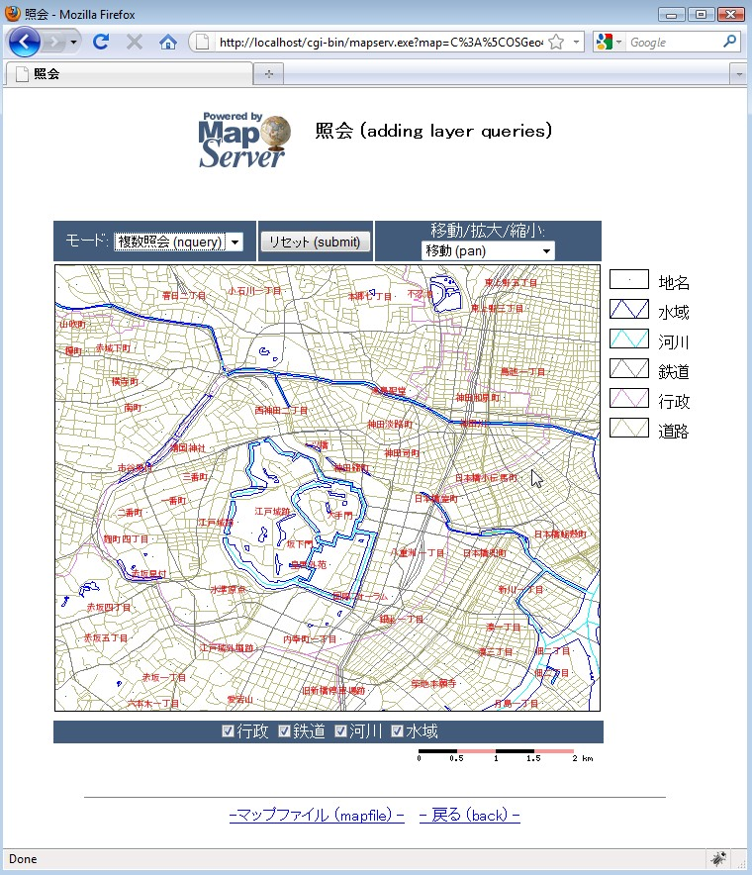
Select the drop-down menu on the left, and select “nquery”, and then click on the map; a query of all layers is executed.

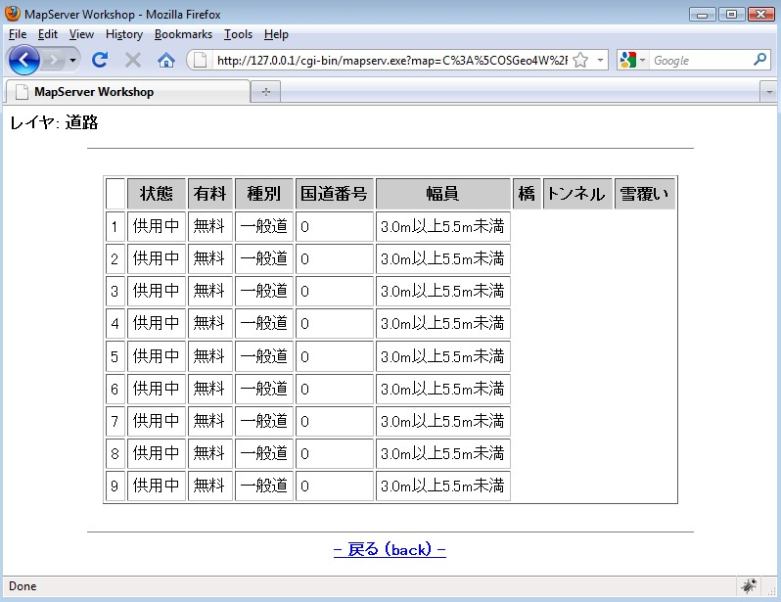
A window should open displaying the query results.

The template file used in this exercise follows:

<!-- MapServer Template -->
<html>
<head>
<meta http-equiv="Content-Type" content="text/html; charset=Shift_JIS">
<title>Æ‰ï</title>
<script>
function doSubmit()
{
document.mapform.submit();
}
</script>
</head>
<body BGCOLOR="white" TEXT="#000000" LINK="#0000FF" VLINK="#0000FF">

<table width="601" align="center" border="0">
<tr>
<td width="593" align=center>
<table cellpadding=10 >
<tr>
<td align=left><img src="/mapserver-tutorial/img/powered_mapserver.jpg"></td>
<td align=left><h3>Æ‰ï (adding layer queries)</h3></td>
</tr>
</table>
<br>
<!-- START OF MAPSERVER FORM -->
<form name="mapform" method="GET" action="/cgi-bin/mapserv.exe">
<!-- HIDDEN MAPSERVER CGI VARIABLES -->
<input type="hidden" name="map" value="[map]">
<input type="hidden" name="imgext" value="[mapext]">
<input type="hidden" name="mapext" value="[mapext]">
<tr>
<td>
<table width="400" border="0">
<tr>
<td bgcolor="#425b7a" width="40%" >

<!-- SPECIFY MAP MODE -->
<div align="center"><font color=white>ƒ‚[ƒh: </font>
<select name="mode">
<option value="browse">•\Ž¦ (browse)</option>
<option value="map">’n} (map)</option>
<option value="query">’PˆêÆ‰ï (query)</option>
<option value="nquery">•¡”Æ‰ï (nquery)</option>
</select>
</div>
</td>
<td bgcolor="#425b7a" width="15%">
<!-- FORM SUBMIT BUTTON →

<div align="center">
<input type="button" name="submitter" value="ƒŠƒZƒbƒg (submit)" onclick="doSubmit()" >
</div>
</td>
<td bgcolor="#425b7a" width="45%">
<!-- ZOOM/PAN CONTROLS -->
<div align="center"><font color=white>ˆÚ“®/Šg‘å/k¬:</font>
<select name="zoom">
<option value="4" [zoom_4_select]>Šg‘å 4x (zoom-in)</option>
<option value="3" [zoom_3_select]>Šg‘å 3x (zoom-in)</option>
<option value="2" [zoom_2_select]>Šg‘å 2x (zoom-in)</option>
<option value="1" [zoom_1_select]>ˆÚ“® (pan)</option>
<option value="-2" [zoom_-2_select]>k¬ 2x (zoom-out)</option>
<option value="-3" [zoom_-3_select]>k¬ 3x (zoom-out)</option>
<option value="-4" [zoom_-4_select]>k¬ 4x (zoom-out)</option>
</select>
</div>
</td>
</tr>
<tr>
<!-- DISPLAY THE MAPSERVER-CREATED MAP IMAGE -->
<td colspan="3" align="right" valign="top">
<input type="image" name="img" src="[img]"
width="550" height="450" border="1">
</td>
<td valign=top >
<!-- DISPLAY THE LEGEND IMAGE -->
<img src="[legend]">
</td>
</tr>
</table>
</td>
</tr>
<tr>
<td>
<table width=560 border="0">
<tr>
<td bgcolor="#425b7a">
<font color="white">
<div align="center">
<input type=checkbox name=layer value="s" [s_check] onclick="doSubmit()" >s
<input type=checkbox name=layer value="“S“¹" [“S“¹_check] onclick="doSubmit()" >“S“¹
<input type=checkbox name=layer value="‰Íì" [‰Íì_check] onclick="doSubmit()" >‰Íì
<input type=checkbox name=layer value="…ˆæ" […ˆæ_check] onclick="doSubmit()" >…ˆæ
</font>
</td>
</tr>
<tr>
<td align=right>
<!-- DISPLAY THE SCALEBAR IMAGE -->
<img src="[scalebar]" border="0">
</td>
</tr>
</table>
</td>
</tr>
</form>
</table>
<br>
<hr noshade width="80%" size="1" align="center">
<center>
<a href="/mapserver-tutorial/example11/example_map.html">-ƒ}ƒbƒvƒtƒ@ƒCƒ‹ (mapfile) -</a>&nbsp;&nbsp;
<a href="/mapserver-tutorial/index.html">- –ß‚é (back) -</a>
</center>
</body>
</html>
Notice the MODE dropdown and its values; MapServer uses the “query” mode to query a single layer, and the “nquery” mode to query multiple layers.

The mapfile used in this exercise is:

MAP
IMAGETYPE PNG
EXTENT 139.72520 35.67139 139.78845 35.70731
SIZE 550 450
IMAGECOLOR 255 255 255
SHAPEPATH "../data"
FONTSET ../fonts/fonts.txt
UNITS dd
WEB
TEMPLATE 'example_template.html'
IMAGEPATH "@osgeo4w@/tmp/ms_tmp/"
IMAGEURL "/ms_tmp/"
MINSCALEDENOM 1000
MAXSCALEDENOM 70000
END
SCALEBAR
UNITS kilometers
BACKGROUNDCOLOR 250 150 150
COLOR 0 0 0
TRANSPARENT on
STYLE 0
STATUS on
LABEL
COLOR 0 0 0
SIZE tiny
END
END
LEGEND
KEYSIZE 40 20
KEYSPACING 10 10

OUTLINECOLOR 0 0 0
IMAGECOLOR 255 255 255
LABEL
TYPE TRUETYPE
FONT pmincho
COLOR 0 0 0
SIZE 12
POSITION CL
PARTIALS FALSE
BUFFER 3
ENCODING "SHIFT_JIS"
END
STATUS ON
END
LAYER
NAME "“¹˜H"
DATA dourokukan
STATUS DEFAULT
TYPE LINE
MAXSCALEDENOM 50000
TOLERANCE 4
TOLERANCEUNITS pixels
HEADER dourokukan_header.html
TEMPLATE dourokukan_template.html
FOOTER dourokukan_footer.html
CLASS
NAME "“¹˜H"
STYLE
COLOR 187 187 127
END
END
END
LAYER
NAME "s"

DATA gyouseikai
STATUS ON
TYPE LINE
CLASS
NAME "s"
STYLE
COLOR 227 127 227
END
END
END
LAYER
NAME "“S“¹"
DATA tetsudokukan
STATUS ON
TYPE LINE
CLASS
NAME "“S“¹"
STYLE
COLOR 128 128 128
END
END
END
LAYER
NAME "‰Íì"
DATA kasenkukan
STATUS ON
TYPE LINE
CLASS
NAME "‰Íì"
STYLE
COLOR 0 255 255
END
END
END

LAYER
NAME "…ˆæ"
DATA suiikikai
STATUS ON
TYPE LINE
CLASS
NAME "…ˆæ"
STYLE
COLOR 0 0 255
END
END
END
LAYER
NAME "’n–¼"
DATA chimei
STATUS DEFAULT
TYPE POINT
LABELITEM "NAMAE"
CLASS
NAME "’n–¼"
STYLE
COLOR 10 100 100
END
LABEL
TYPE TRUETYPE
FONT pgothic
COLOR 220 20 20
SIZE 7
POSITION CL
PARTIALS FALSE
BUFFER 5
ENCODING "SHIFT_JIS"
END
END
END
END
Notice the TEMPLATE parameter set in dourokukan layer; the new parameters are described below:

TOLERANCE
This is the range of acceptance for a given query.
TOLERANCEUNITS
Specify the units for the TOLERANCE parameter.
HEADER
The header file displays the HTML shown before the results.
TEMPLATE
The template file itself contains the query results.
FOOTER
The footer file contains the HTML shown after the query results.

dourokukan_header.html

<!-- MapServer Template -->
<html>
<head>
<meta http-equiv="Content-Type" content="text/html; charset=Shift_JIS">
<title>MapServer Workshop</title>
</head>
<font size+3><b>¥ì¥¤¥ä: Æ»Ï©</b></font><p>
<hr noshade width="80%" size="1" align="center">
<br>
<div align=center>
<table cellpadding=5 cellspacing=2 border=1>
<tr bgcolor=#CCCCCC>
<td bgcolor=#ffffff>&nbsp;</td>
<th>¾õÂÖ</th>
<th>ÍÎÁ</th>
<th>¼ïÊÌ</th>
<th>¹ñÆ»ÈÖ¹æ</th>
<th>Éý°÷</th>
<th>¶¶</th>
<th>¥È¥ó¥Í¥ë</th><th>ÀãÊ¤¤¤</th></tr>
dourokukan_template.html

<!-- MapServer Template -->
<tr>
<td>[JOUTAI]</td>
<td>[YURYO]</td>
<td>[SYUBETSU]</td>
<td>[KOKUBANGO]</td>
<td>[FUKUIN]</td>
<td>[HASHI]</td>
<td>[TONNERU]</td>
<td>[YUKIOOI]</td>
</tr>

dourorkukan_footer.html

<!-- MapServer Template -->
</table>
</div>
<br>
<hr noshade width="80%" size="1" align="center">
<div align="center"><b><a href="javascript:history.back()">- Ìá¤ë (back) -</a><br>
</html>

Note that each template file (HEADER, FOOTER, TEMPLATE) must always contain the MapServer “magic string” of <!-- MapServer Template -->

The TEMPLATE contains field names in square brackets (such as “JOUTAI”) that are populated with values by MapServer during run-time.

Using WMS Services with MapServer

About WMS
The Open Geospatial Consortium (OGC, http://www.opengeospatial.org/) is an international group of organizations that focus on sharing geospatial information through standards. One of the OGC's most widely used standards is the Web Map Server (WMS) specification, which shares images (such as GIF, PNG, JPEG) of spatial data across remote servers (in other words: the actual data is not transferred, only an image of the data is transferred from a remote WMS server).

MapServer has always been one of the early adopters of OGC standards. MapServer's OGC standard support is well documented at: http://www.mapserver.org/ogc/ This section will discuss MapServer's WMS support. MapServer can act both as a WMS server (serving images of data to other servers), or as a WMS client (request and use remote images of data from other servers). Some relevant documents from MapServer are:

- MapServer WMS Server Howto: http://www.mapserver.org/ogc/wms_server.html
- MapServer WMS Client Howto: http://www.mapserver.org/ogc/wms_client.html

Exercise 12: Serving WMS Layers Through MapServer (WMS Server)
In this exercise we will add a few mandatory parameters to our mapfile so that it can be served through the WMS standard.
Step1: Configure Your Mapfile

The mapfile used in this exercise is:
MAP
NAME "mapserver_tutorial_wms_server"
IMAGETYPE PNG
EXTENT 139.72520 35.67139 139.78845 35.70731
SIZE 550 450
IMAGECOLOR 255 255 255
SHAPEPATH "../data"
FONTSET ../fonts/fonts.txt
UNITS dd

WEB
TEMPLATE 'example_template.html'
IMAGEPATH "@osgeo4w@/tmp/ms_tmp/"
IMAGEURL "/ms_tmp/"
MINSCALEDENOM 1000
MAXSCALEDENOM 70000
METADATA
"wms_title" "MapServer Tutorial WMS Server"
"wms_onlineresource" "http://127.0.0.1/cgi-bin/mapserv.exe?MAP=@osgeo4w@/apps/mapserver-tutorial/example12.map"
"wms_srs" "EPSG:4301 EPSG:4269 EPSG:4326"
"wms_abstract" "This demonstration server shows how to setup a
MapServer .map file to serve data through the WMS
standard."
END
END
PROJECTION
"init=epsg:4301"
END
LAYER
NAME "roads"
METADATA
"wms_title" "Roads"
END
DATA dourokukan
STATUS ON
TYPE LINE
MAXSCALEDENOM 50000
CLASS
NAME "roads"
STYLE
COLOR 187 187 127
END
END
PROJECTION
"init=epsg:4301"

END
END
LAYER
NAME "administrative"
METADATA
"wms_title" "Administrative"
END
DATA gyouseikai
STATUS ON
TYPE LINE
CLASS
NAME "Administrative"
STYLE
COLOR 227 127 227
END
END
PROJECTION
"init=epsg:4301"
END
END
LAYER
NAME "rail"
METADATA
"wms_title" "Rail"
END
DATA tetsudokukan
STATUS ON
TYPE LINE
CLASS
NAME "Rail"
STYLE
COLOR 128 128 128
END
END

PROJECTION
"init=epsg:4301"
END
END
LAYER
NAME "rivers"
METADATA
"wms_title" "Rivers"
END
DATA kasenkukan
STATUS ON
TYPE LINE
CLASS
NAME "Rivers"
STYLE
COLOR 0 255 255
END
END
PROJECTION
"init=epsg:4301"
END
END
LAYER
NAME "water"
METADATA
"wms_title" "Water"
END
DATA suiikikai
STATUS ON
TYPE LINE
CLASS
NAME "Water"
STYLE
COLOR 0 0 255

END
END
PROJECTION
"init=epsg:4301"
END
END
LAYER
NAME "places"
METADATA
"wms_title" "Place name"
END
DATA chimei
STATUS ON
TYPE POINT
LABELITEM "NAMAE"
CLASS
NAME "Places"
STYLE
COLOR 10 100 100
END
LABEL
TYPE TRUETYPE
FONT pgothic
COLOR 220 20 20
SIZE 7
POSITION CL
PARTIALS FALSE
BUFFER 5
ENCODING "SHIFT_JIS"
END
END
PROJECTION
"init=epsg:4301"
END
END END
The highlighed text shows the required parameters to serve data through the WMS standard with MapServer, and they are described next:

WMS_TITLE
This metadata must be set in the WEB object and in every layer that you want served through WMS. Use it to describe your data. All possible WMS metadata items are documented at: http://www.mapserver.org/ogc/wms_server.html#reference-section

WMS_ONLINERESOURCE
This metadata item must be set in the WEB object; it is the URL to your mapserv.exe executable, and in our example includes the full path to our mapfile. More information about this metadata item can be read at: http://www.mapserver.org/ogc/wms_server.html#more-about-the-online-resource-url

PROJECTION
In order to serve data through any OGC standard, you must specify the projection that the data is in. Each layer must have a PROJECTION object, as well as a PROJECTION set at the MAP object level. Please read the MapServer documentation on the PROJECTION object: http://www.mapserver.org/mapfile/projection.html

Step2: Validate Your Server's Capabilities
Now that we have configured our mapfile for serving WMS, we must check that it is configured properly for the standard. We do this by using the onlineresource URL in a browser, and add the following to it: “&SERVICE=WMS&VERSION=1.1.1&REQUEST=GetCapabilities “. In our example, the full request is:

http://127.0.0.1/cgi-bin/mapserv.exe?MAP=C:/OSGeo4W/apps/mapserver-tutorial/example12/example.map&SERVICE=wms&VERSION=1.1.1&REQUEST=GetCapabilities

Generally that request is referred to as the GetCapabilities request. If you execute it in a browser, you will be asked to save a file: rename this file so that it has a .xml extension (such as 'mapserv.xml'). Then open this file in a text editor. You should see a response from your WMS server, describing the layers available, such as:

<?xml version='1.0' encoding="ISO-8859-1" standalone="no" ?>
<!DOCTYPE WMT_MS_Capabilities SYSTEM "http://schemas.opengis.net/wms/1.1.1/WMS_MS_Capabilities.dtd"
[
<!ELEMENT VendorSpecificCapabilities EMPTY>
]> <!-- end of DOCTYPE declaration -->
<WMT_MS_Capabilities version="1.1.1">
<!-- MapServer version 5.2.2 OUTPUT=GIF OUTPUT=PNG OUTPUT=JPEG OUTPUT=WBMP OUTPUT=SWF OUTPUT=SVG SUPPORTS=PROJ SUPPORTS=AGG SUPPORTS=FREETYPE SUPPORTS=ICONV SUPPORTS=FRIBIDI SUPPORTS=WMS_SERVER SUPPORTS=WMS_CLIENT SUPPORTS=WFS_SERVER SUPPORTS=WFS_CLIENT SUPPORTS=WCS_SERVER SUPPORTS=SOS_SERVER SUPPORTS=FASTCGI SUPPORTS=THREADS SUPPORTS=GEOS SUPPORTS=RGBA_PNG INPUT=JPEG INPUT=POSTGIS INPUT=OGR INPUT=GDAL INPUT=SHAPEFILE -->
<Service>
<Name>OGC:WMS</Name>
<Title>MapServer Tutorial WMS Server</Title>
<Abstract>This demonstration server shows how to setup a MapServer .map file to serve data through the WMS standard.</Abstract>
<OnlineResource xmlns:xlink="http://www.w3.org/1999/xlink" xlink:href="http://127.0.0.1/cgi-bin/mapserv.exe?MAP=C:\OSGeo4W/apps/mapserver-tutorial/example12.map&amp;"/>
<ContactInformation>
</ContactInformation>
</Service>
<Capability>
<Request>
<GetCapabilities>
<Format>application/vnd.ogc.wms_xml</Format>
<DCPType>
<HTTP>
<Get><OnlineResource xmlns:xlink="http://www.w3.org/1999/xlink" xlink:href="http://127.0.0.1/cgi-bin/mapserv.exe?MAP=C:\OSGeo4W/apps/mapserver-tutorial/example12.map&amp;"/></Get>
<Post><OnlineResource xmlns:xlink="http://www.w3.org/1999/xlink" xlink:href="http://127.0.0.1/cgi-bin/mapserv.exe?MAP=C:\OSGeo4W/apps/mapserver-tutorial/example12.map&amp;"/></Post>
</HTTP>
</DCPType>

</GetCapabilities>
<GetMap>
<Format>image/gif</Format>
<Format>image/png</Format>
<Format>image/png; mode=24bit</Format>
<Format>image/jpeg</Format>
<Format>image/vnd.wap.wbmp</Format>
<Format>image/tiff</Format>
<Format>image/svg+xml</Format>
<DCPType>
<HTTP>
<Get><OnlineResource xmlns:xlink="http://www.w3.org/1999/xlink" xlink:href="http://127.0.0.1/cgi-bin/mapserv.exe?MAP=C:\OSGeo4W/apps/mapserver-tutorial/example12.map&amp;"/></Get>
<Post><OnlineResource xmlns:xlink="http://www.w3.org/1999/xlink" xlink:href="http://127.0.0.1/cgi-bin/mapserv.exe?MAP=C:\OSGeo4W/apps/mapserver-tutorial/example12.map&amp;"/></Post>
</HTTP>
</DCPType>
</GetMap>
<GetFeatureInfo>
<Format>text/plain</Format>
<Format>application/vnd.ogc.gml</Format>
<DCPType>
<HTTP>
<Get><OnlineResource xmlns:xlink="http://www.w3.org/1999/xlink" xlink:href="http://127.0.0.1/cgi-bin/mapserv.exe?MAP=C:\OSGeo4W/apps/mapserver-tutorial/example12.map&amp;"/></Get>
<Post><OnlineResource xmlns:xlink="http://www.w3.org/1999/xlink" xlink:href="http://127.0.0.1/cgi-bin/mapserv.exe?MAP=C:\OSGeo4W/apps/mapserver-tutorial/example12.map&amp;"/></Post>
</HTTP>
</DCPType>
</GetFeatureInfo>
<DescribeLayer>
<Format>text/xml</Format>
<DCPType>

<HTTP>
<Get><OnlineResource xmlns:xlink="http://www.w3.org/1999/xlink" xlink:href="http://127.0.0.1/cgi-bin/mapserv.exe?MAP=C:\OSGeo4W/apps/mapserver-tutorial/example12.map&amp;"/></Get>
<Post><OnlineResource xmlns:xlink="http://www.w3.org/1999/xlink" xlink:href="http://127.0.0.1/cgi-bin/mapserv.exe?MAP=C:\OSGeo4W/apps/mapserver-tutorial/example12.map&amp;"/></Post>
</HTTP>
</DCPType>
</DescribeLayer>
<GetLegendGraphic>
<Format>image/gif</Format>
<Format>image/png</Format>
<Format>image/png; mode=24bit</Format>
<Format>image/jpeg</Format>
<Format>image/vnd.wap.wbmp</Format>
<DCPType>
<HTTP>
<Get><OnlineResource xmlns:xlink="http://www.w3.org/1999/xlink" xlink:href="http://127.0.0.1/cgi-bin/mapserv.exe?MAP=C:\OSGeo4W/apps/mapserver-tutorial/example12.map&amp;"/></Get>
<Post><OnlineResource xmlns:xlink="http://www.w3.org/1999/xlink" xlink:href="http://127.0.0.1/cgi-bin/mapserv.exe?MAP=C:\OSGeo4W/apps/mapserver-tutorial/example12.map&amp;"/></Post>
</HTTP>
</DCPType>
</GetLegendGraphic>
<GetStyles>
<Format>text/xml</Format>
<DCPType>
<HTTP>
<Get><OnlineResource xmlns:xlink="http://www.w3.org/1999/xlink" xlink:href="http://127.0.0.1/cgi-bin/mapserv.exe?MAP=C:\OSGeo4W/apps/mapserver-tutorial/example12.map&amp;"/></Get>
<Post><OnlineResource xmlns:xlink="http://www.w3.org/1999/xlink" xlink:href="http://127.0.0.1/cgi-bin/mapserv.exe?MAP=C:\OSGeo4W/apps/mapserver-tutorial/example12.map&amp;"/></Post>
</HTTP>
</DCPType>

</GetStyles>
</Request>
<Exception>
<Format>application/vnd.ogc.se_xml</Format>
<Format>application/vnd.ogc.se_inimage</Format>
<Format>application/vnd.ogc.se_blank</Format>
</Exception>
<VendorSpecificCapabilities />
<UserDefinedSymbolization SupportSLD="1" UserLayer="0" UserStyle="1" RemoteWFS="0"/>
<Layer>
<Name>mapserver_tutorial_wms_server</Name>
<Title>MapServer Tutorial WMS Server</Title>
<SRS>EPSG:4301</SRS>
<SRS>EPSG:4269</SRS>
<SRS>EPSG:4326</SRS>
<LatLonBoundingBox minx="139.725" miny="35.6714" maxx="139.788" maxy="35.7073" />
<BoundingBox SRS="EPSG:4301"
minx="139.725" miny="35.6714" maxx="139.788" maxy="35.7073" />
<ScaleHint min="0.498902848429637" max="34.9231993900746" />
<Layer queryable="0" opaque="0" cascaded="0">
<Name>roads</Name>
<Title>Roads</Title>
<SRS>EPSG:4301</SRS>
<LatLonBoundingBox minx="139.563" miny="35.5247" maxx="139.918" maxy="35.8176" />
<BoundingBox SRS="EPSG:4301"
minx="139.563" miny="35.5247" maxx="139.918" maxy="35.8176" />
<Style>
<Name>default</Name>
<Title>default</Title>
<LegendURL width="70" height="23">
<Format>image/png</Format>
<OnlineResource xmlns:xlink="http://www.w3.org/1999/xlink" xlink:type="simple" xlink:href="http://127.0.0.1/cgi-bin/mapserv.exe?

MAP=C:\OSGeo4W/apps/mapserver-tutorial/example12.map&amp;version=1.1.1&amp;service=WMS&amp;request=GetLegendGraphic&amp;layer=roads&amp;format=image/png&amp;STYLE=default"/>
</LegendURL>
</Style>
<ScaleHint min="0" max="24.9451424214819" />
</Layer>
. . .
</Capability>
</WMT_MS_Capabilities>

If you are going to add a WMS layer from a remote server, it is recommended that you look at the server's GetCapabilities document. In our example above, you can see that our abstract and titles for all of the layers are displayed in the GetCapabilities document, as well as other important information such as what image formats the data is available in, and what projections (or “SRS”) we can request the data in. If you have a problem with your WMS service, a “WARNING” tag will be included in your GetCapabilities document.

Step3: Request a Map from your Server
Now that you have verified that the capabilities of your WMS server are valid, you can now request an map image from your WMS server. The WMS specification uses a GetMap request to request a map from a remote WMS server. Please see the MapServer documentation for a definition of all of the parameters required for a GetMap request: http://www.mapserver.org/ogc/wms_server.html#test-with-a-getmap-request

In our example, our GetMap requests looks like this:

http://127.0.0.1/cgi-bin/mapserv.exe?MAP=C:\OSGeo4W/apps/mapserver-tutorial/example12/example.map&SERVICE=wms&VERSION=1.1.1&REQUEST=GetMap&LAYERS=mapserver_tutorial_wms_server&SRS=EPSG:4301&BBOX=139.72520,35.67139,139.78845,35.70731&FORMAT=image/png&WIDTH=550&HEIGHT=450

In our example, the GetMap request will return an image such as:

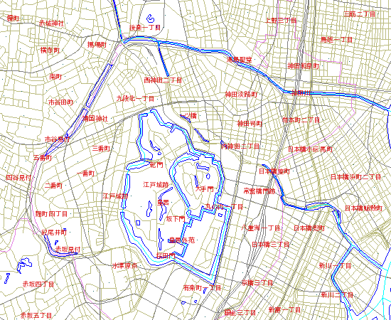
MapServer will return a map image with given a GetMap request, or it will return an error.

Exercise 13: Consuming Remote WMS Layers in MapServer (WMS Client)
In this exercise we will add a layer from a remote WMS service to our mapfile.

Step1: Choose a remote WMS Service
Locating WMS services is not easy, as there is no official list of services (at the time of writing this document). For your benefit here are some possible WMS services:

Description | More Information | Onlineresource URL
Base map data for Japan | http://www.finds.jp/wsdocs/kibanwms/index.html | http://www.finds.jp/ws/kiban25000wms.cgi?
Landslide Map Database for Japan | http://lsweb1.ess.bosai.go.jp/jisuberi/jisuberi_mini/index.asp | http://lsweb1.ess.bosai.go.jp/wmsconnector/com.esri.wms.Esrimap
OnEarth, JPL WMS Server | http://onearth.jpl.nasa.gov/ | http://wms.jpl.nasa.gov/wms.cgi
Geography Network for Japan | http://www.geographynetwork.ne.jp/ | http://www.geographynetwork.ne.jp/ogc/wms?ServiceName=basemap_wms
Agricultural/Environmental for Japan | http://habs.dc.affrc.go.jp/index.html | http://habs.dc.affrc.go.jp/geowebcache/wms?
GeoGrid WMS | http://docs.geogrid.org/Applications/PublicWMS | http://carteb.geogrid.org/mapserv/qqm

Step2: Review the WMS Server's GetCapabilities
In this example we chose GeoGrid's geology WMS service (http://geodata1.geogrid.org/mapserv/g1000k/g1000ke?). To look at their service's capabilities we would execute a GetCapabilities request, such as:

http://geodata1.geogrid.org/mapserv/g1000k/g1000ke?SERVICE=wms&VERSION=1.1.1&REQUEST=GetCapabilities

A portion of their GetCapabilities response follows:

<Layer>
<Name>g1000ke</Name>
<Title>1/1,000,000 geological map of Japan (English)</Title>
<SRS>esri:54004</SRS>
<SRS>epsg:4326</SRS>
<SRS>epsg:4612</SRS>
<SRS>epsg:4301</SRS>
<LatLonBoundingBox minx="122.943" miny="20.4586" maxx="153.99" maxy="45.5565" />
<BoundingBox SRS="EPSG:4612"
minx="122.943" miny="20.4586" maxx="153.99" maxy="45.5565" />
<Layer queryable="0" opaque="0" cascaded="0">
<Name>area</Name>
<Title>Area</Title>
<Abstract>1/1,000,000 geological map (Polygon data)</Abstract>
<SRS>EPSG:4612</SRS>
<LatLonBoundingBox minx="122.943" miny="20.4586" maxx="153.99" maxy="45.5565" />
<BoundingBox SRS="EPSG:4612"
minx="122.943" miny="20.4586" maxx="153.99" maxy="45.5565" />
<Style>
<Name>default</Name>
<Title>default</Title>
<LegendURL width="20" height="15">
<Format>image/png</Format>
<OnlineResource xmlns:xlink="http://www.w3.org/1999/xlink" xlink:type="simple" xlink:href="http://geodata1.geogrid.org/mapserv/g1000k/g1000ke?version=1.1.1&amp;service=WMS&amp;request=GetLegendGraphic&amp;layer=area&amp;format=image/png"/>
</LegendURL>
</Style>
<ScaleHint min="0" max="4989.02848429637" />
</Layer>
<Layer queryable="0" opaque="0" cascaded="0">
<Name>line</Name>
<Title>Line</Title>

<Abstract>1/1,000,000 geological map (Fault and boundary data)</Abstract>
<SRS>EPSG:4612</SRS>
<LatLonBoundingBox minx="122.943" miny="20.4586" maxx="153.99" maxy="45.5565" />
<BoundingBox SRS="EPSG:4612"
minx="122.943" miny="20.4586" maxx="153.99" maxy="45.5565" />
<Style>
<Name>default</Name>
<Title>default</Title>
<LegendURL width="20" height="15">
<Format>image/png</Format>
<OnlineResource xmlns:xlink="http://www.w3.org/1999/xlink" xlink:type="simple" xlink:href="http://geodata1.geogrid.org/mapserv/g1000k/g1000ke?version=1.1.1&amp;service=WMS&amp;request=GetLegendGraphic&amp;layer=line&amp;format=image/png"/>
</LegendURL>
</Style>
<ScaleHint min="0" max="4989.02848429637" />
</Layer>
<Layer queryable="0" opaque="0" cascaded="0">
<Name>label</Name>
<Title>Label</Title>
<Abstract>1/1,000,000 geological map (Label information)</Abstract>
<SRS>EPSG:4612</SRS>
<LatLonBoundingBox minx="122.943" miny="20.4586" maxx="153.99" maxy="45.5565" />
<BoundingBox SRS="EPSG:4612"
minx="122.943" miny="20.4586" maxx="153.99" maxy="45.5565" />
<ScaleHint min="0" max="4989.02848429637" />
</Layer>

From the GetCapabilities response, we can see that there is a “ g1000ke” layer available, and that server is providing the data in the same projection as our local data (EPSG:4301).

Step3: Add a WMS Layer to our Mapfile
To add a WMS layer to our mapfile, you can follow the instructions in the MapServer WMS Client document: http://www.mapserver.org/ogc/wms_client.html
Our example WMS layer follows:

LAYER
NAME "geology-wms"
TYPE RASTER
STATUS OFF
CONNECTION "http://geodata1.geogrid.org/mapserv/g1000k/g1000ke?"
CONNECTIONTYPE WMS
METADATA
"wms_srs" "EPSG:4301"
"wms_name" "g1000ke"
"wms_server_version" "1.1.1"
"wms_format" "image/png"
END
END

Here is a description of the important parameters of this layer:

TYPE
Since we are requesting a PNG image from the WMS server, the type is set to RASTER.

CONNECTION
This is the onlineresource URL for the remote WMS server.

CONNECTIONTYPE
Must be set to 'WMS'.

WMS_SRS
This is the projection that we request the data to be in. We have already verified that their remote WMS server serves the data in this projection.
WMS_NAME
This is the name of the remote WMS layer, as specified in their GetCapabilities response.

WMS_SERVER_VERSION
This is the WMS version as obtained through the GetCapabilities response.

WMS_FORMAT
This is the format that we want the map image in. We have already verified that the PNG format is available on their WMS server.

Step4: Generate a Map
Finally we can try to view our local layers with this remote WMS layer. The exercise HTML page has a working link to generate a map image, but you can also use MapServer's shp2img.exe commandline utility to test your mapfile. More information about shp2img can be found at: http://www.mapserver.org/utilities/shp2img.html

Execute the following steps:

- Click on the “OSGeo4W” shortcut on your desktop. A commandline shell window should open.
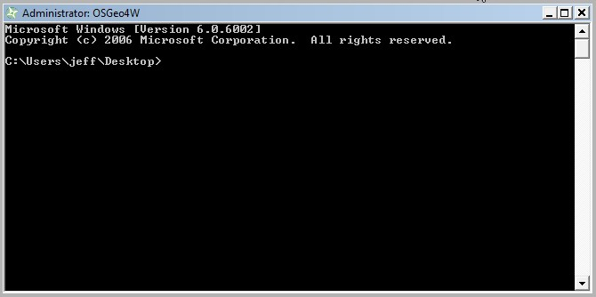
- CD (change directory) to the example13 directory.
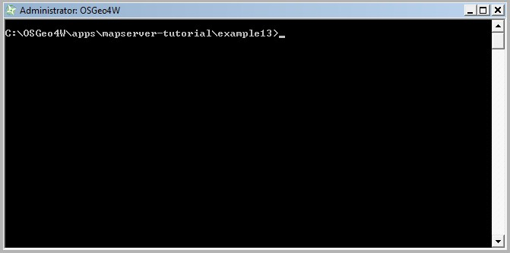
- Execute: shp2img -m example.map -o test.png -map_debug 3
(this should generate a 'test.png' map image, or display an error)
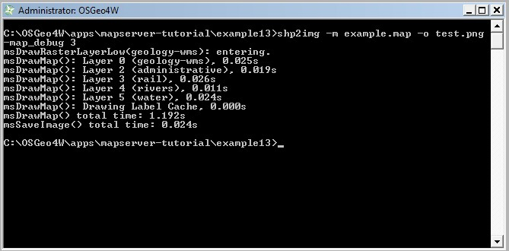

- Drag 'test.png' into your Web browser.
(if you have a blank image, open example13/example.map in a text editor and replace all 'STATUS OFF' values with 'STATUS ON' and retry shp2img)
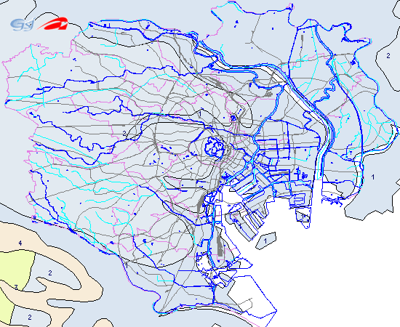
You should now see a map image of our local layers overlayed on top of the remote WMS server (geology) layer.

Using OpenLayers with Your MapServer Data

About OpenLayers
OpenLayers (http://www.openlayers.org/) is another project of the Open Source Geospatial Foundation (OSGeo), which is a very popular JavaScript API for creating online mapping applications. OpenLayers is designed for use with WMS layers, so we will use it in our example to display our WMS layers that we configured in Example12, and the GeoGrid WMS service.

Exercise 14: Creating a Simple OpenLayers Viewer
In this exercise we will use OpenLayers to create a simple JavaScript viewer for our own WMS-served layers, and the GeoGrid WMS layer.

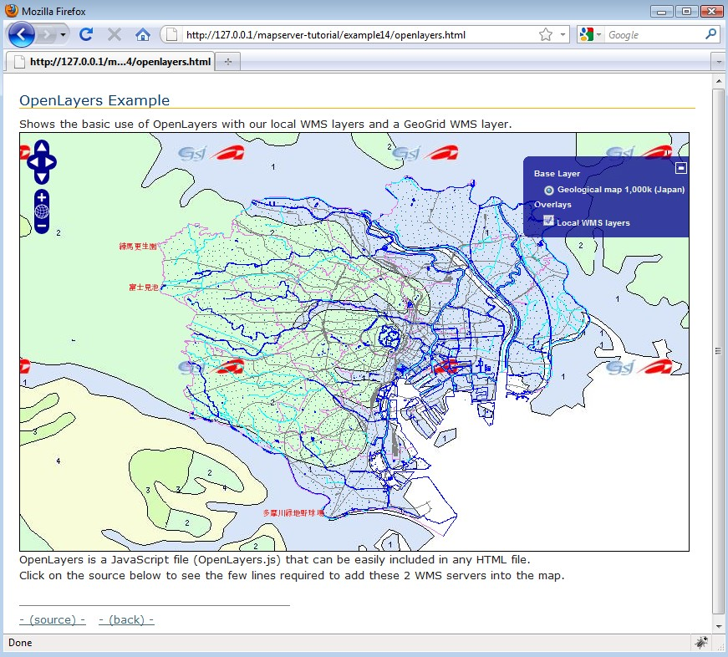
The HTML file used to create this interface follows:

<html xmlns="http://www.w3.org/1999/xhtml">
<head>
<meta http-equiv="Content-Type" content="text/html; charset=ISO-8859-1"/>
<link rel="stylesheet" href="style.css" type="text/css" />
<style type="text/css">
#map {
width: 800px;
height: 500px;
border: 1px solid black;
}
</style>
<script src="OpenLayers.js"></script>
<script type="text/javascript">
var lon = 139.7245;
var lat = 35.6816;
var zoom = 11;
var map, layer;
function init(){
map = new OpenLayers.Map( 'map' );

g1000ke = new OpenLayers.Layer.WMS( "Geological map 1,000k (Japan)",
"http://geodata1.geogrid.org/mapserv/g1000k/g1000ke",
{layers: 'g1000ke'} );
map.addLayer(g1000ke);

localWMS = new OpenLayers.Layer.WMS( "Local WMS layers",
"http://127.0.0.1/cgi-bin/mapserv.exe?MAP=C:/OSGeo4W/apps/mapserver-tutorial/example12/example.map",
{layers: 'mapserver_tutorial_wms_server', transparent: true}, {isBaseLayer: false} );
map.addLayer(localWMS);

map.setCenter(new OpenLayers.LonLat(lon, lat), zoom);
map.addControl( new OpenLayers.Control.LayerSwitcher() );

}
</script>
</head>
<body onload="init()">
<h1 id="title">OpenLayers Example</h1>
<div id="tags">
</div>
<p id="shortdesc">
Shows the basic use of OpenLayers with our local WMS layers and a GeoGrid WMS layer.
</p>
<div id="map" class="smallmap"></div>
<div id="docs">
OpenLayers is a JavaScript file (OpenLayers.js) that can be easily included in any HTML file.<br>Click on the source
below to see the few lines required to add these 2 WMS servers into the map.<br>
<br>
<hr noshade width="40%" size="1" align="left">
<a href="/mapserver-tutorial/example14/openlayers_source.html">- (source) -</a>&nbsp;&nbsp;
<a href="/mapserver-tutorial/index.html">- (back) -</a>
</div>
</body>
</html>

As you can see above, the HTML file required to generate this viewer is very small. The important parts of this file are as follows:

- the <script> tag points to OpenLayers.js
This is a compressed version of the OpenLayers library. Instructions to generate this file are found at: http://docs.openlayers.org/library/deploying.html
- the OpenLayers.Layer.WMS constructor is used to point to our local WMS service, and the GeoGrid service. Documentation on the contructor is found at: http://dev.openlayers.org/apidocs/files/OpenLayers/Layer/WMS-js.html
- the map.SetCenter function is used to specify the map extents in the viewer. Documentation on this function can be found at: http://dev.openlayers.org/apidocs/files/OpenLayers/Map-js.html#OpenLayers.Map.setCenter

And that is all that is required to generate an OpenLayers viewer.

Using Quantum GIS with MapServer

About Quantum GIS
Quantum GIS, or QGIS, (http://www.qgis.org/) is another project of the Open Source Geospatial Foundation (OSGeo), which is a fully featured desktop GIS. It can operate on many different Operating Systems, and supports many vector, raster, database, and OGC formats.
One of the many capabilities provided by QGIS is the ability to export your QGIS styles to a MapServer mapfile.

Exercise 15: Add a WMS Layer in QGIS and Export to MapServer

Step1: Install QGIS Through OSGeo4W

In the Advanced interface for OSGeo4W, in the “Desktop” section, install the “qgis-full” package.

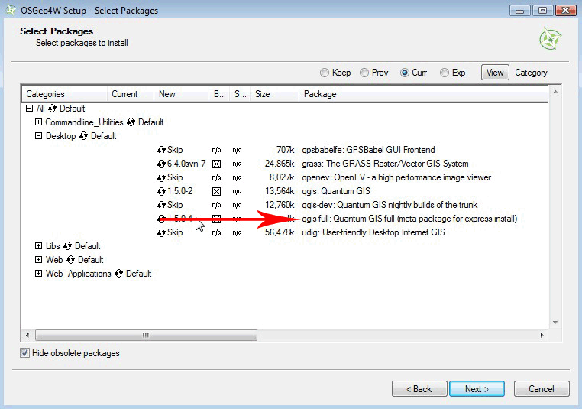

Step3: Start QGIS
Goto Start Menu/Programs/OSGeo4W and select “Quantum GIS”.
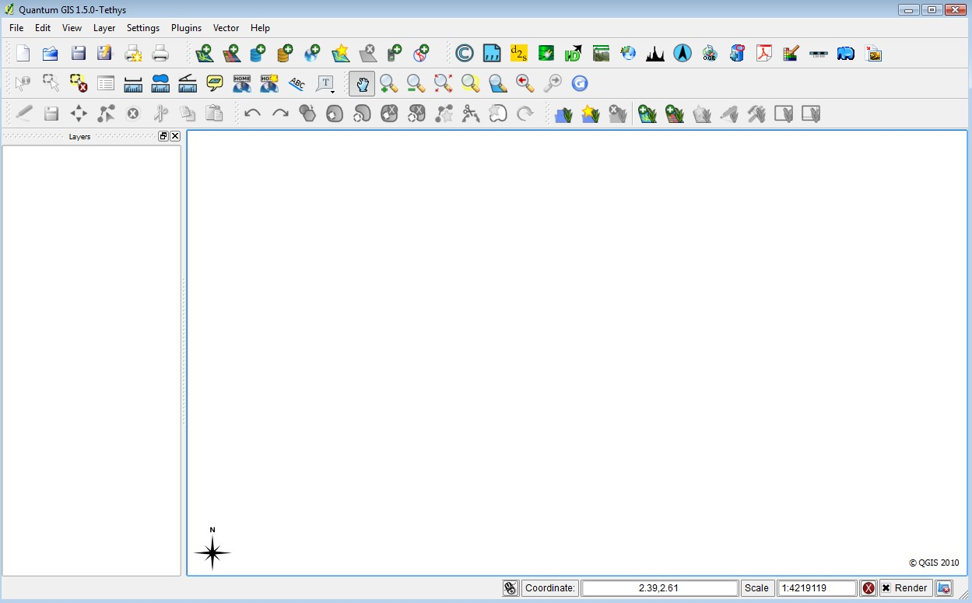
Step4: Add all of the Exercise Shapefiles
- in the Layer menu, select “Add vector layer”
- browse to the location of the files (OSGeo4W\apps\mapserver-tutorial\data\)
- select all shapefiles
- experiment with styling by clicking on the layer name in the legend
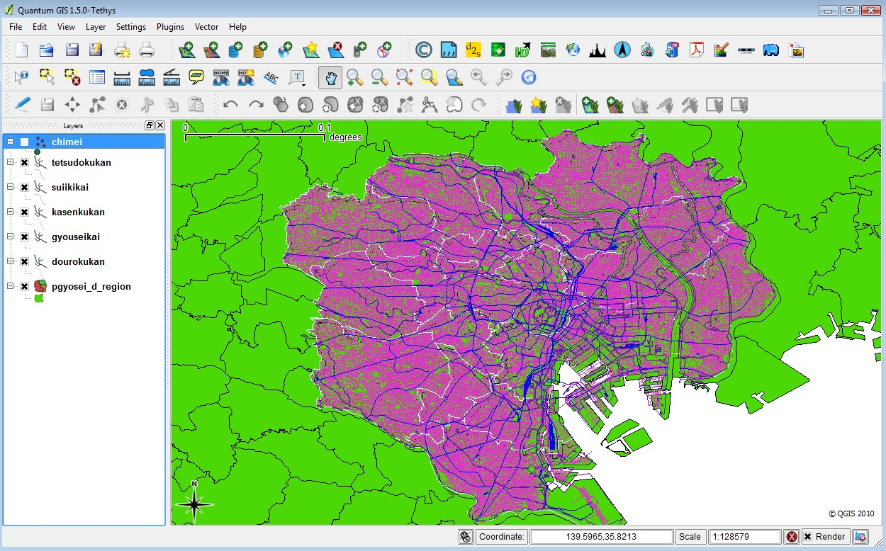

Step5: Add the GeoGrid WMS Layer
- in the Layer menu, select “Add WMS Layer”
- You should see the “Add Layer(s) from a Server” window
- Select “New”
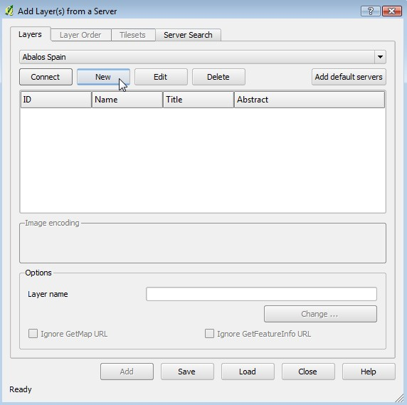

- In the “Create a new WMS connection” window enter “GeoGrid” for the name, and for the URL: http://geodata1.geogrid.org/mapserv/g1000k/g1000ke?
- From the dropdown in the “Add Layer(s) from a Server” window select the “GeoGrid” one
- Click “Connect” (the GetCapabilities will be parsed and the layer names will be read)
- Highlight the first layer, named “g1000ke” (see the following image) and click “Add”
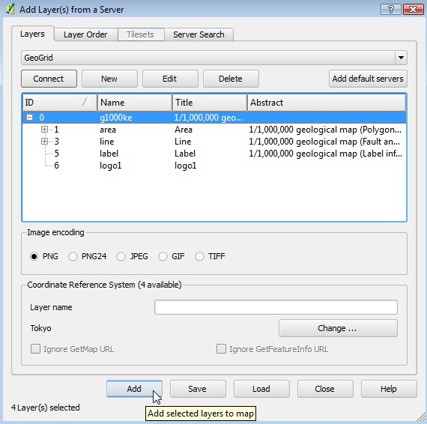
- close the “Add Layer(s) from a Server” window
- the GeoGrid layer should be overlayed on your map image
- reorder the layers in the legend so that the GeoGrid layer is at the bottom of the image, and turn off the 'pgyosei_d_region' layer

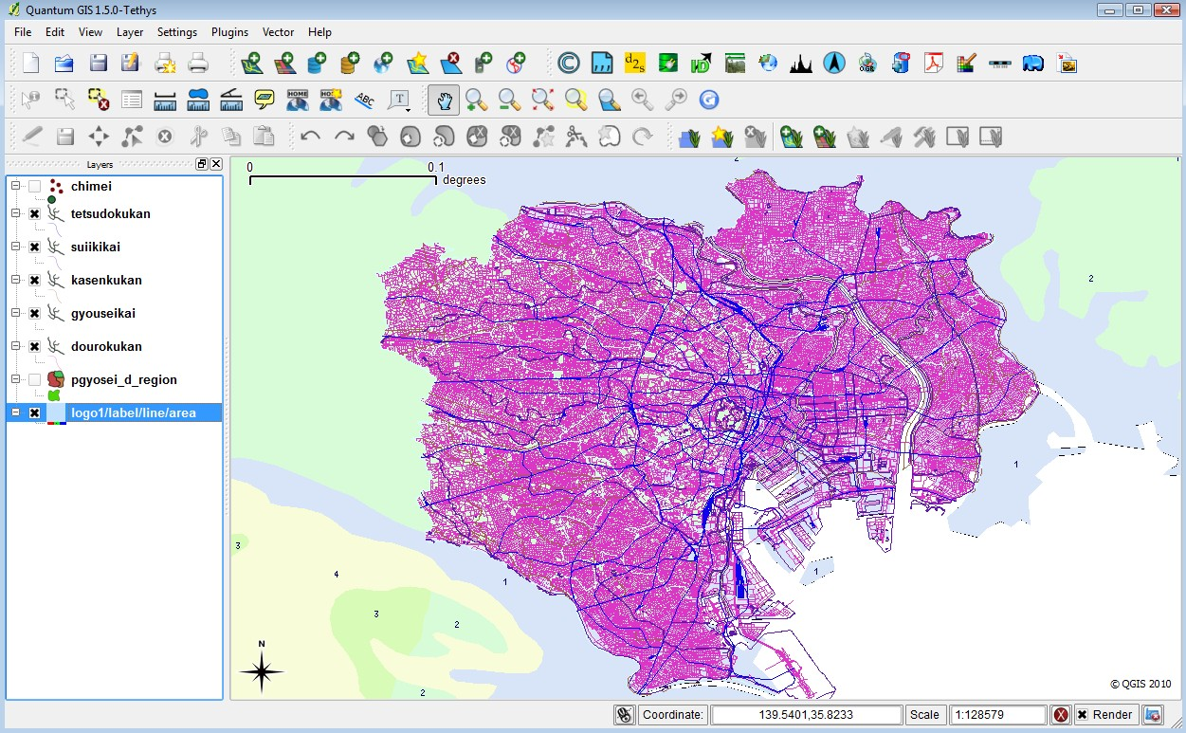
- save your project (File/Save Project)
- goto Plugins/MapServer Export
- the MapServer Export window is now displayed (see the following image). Configure the options you wish for your mapfile, and press <OK>
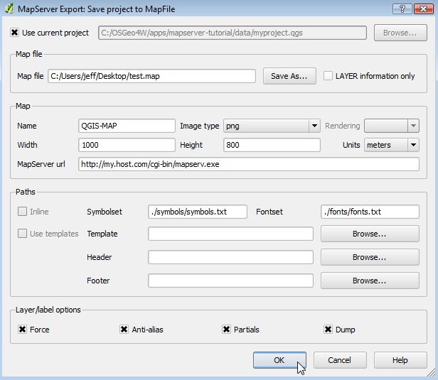
- a mapfile should have been created with the styles that you chose, including a layer for the GeoGrid WMS server. It is recommended that you open the mapfile in a text editor and correct any mistakes. Test the mapfile with the shp2img commandline utility.

# Map file created from QGIS project file C:/OSGeo4W/apps/mapserver-tutorial/data/myproject.qgs
# Edit this file to customize for your map interface
# (Created with PyQgis MapServer Export plugin)
MAP
NAME "QGIS-MAP"
# Map image size
SIZE 1000 800
UNITS meters

EXTENT 139.485746 35.533769 139.994240 35.823828
. . .

. . .
LAYER
NAME 'logo1/label/line/area'
TYPE RASTER
DUMP true
TEMPLATE fooOnlyForWMSGetFeatureInfo
EXTENT 139.485746 35.533769 139.994240 35.823828
CONNECTIONTYPE WMS
CONNECTION 'http://geodata1.geogrid.org/mapserv/g1000k/g1000ke?'
METADATA
'ows_name' 'logo1,label,line,area'
'wms_server_version' '1.1.1'
'ows_srs' 'EPSG:4301'
'wms_format' 'image/png'
'wms_style' ',,,'
END
METADATA
'ows_title' 'logo1/label/line/area'
END
STATUS OFF
TRANSPARENCY 100
PROJECTION
'proj=longlat'
'ellps=WGS84'
'datum=WGS84'
'no_defs'
END
END

Using WFS Services with MapServer

About WFS
Another popular standard introduced by the Open Geospatial Consortium is the Web Feature Service (WFS) specification, which shares features and attributes of vector data across remote servers in the form of GML (Geography Markup Language).

MapServer has always been one of the early adopters of OGC standards. MapServer's OGC standard support is well documented at: http://www.mapserver.org/ogc/ This section will discuss MapServer's WFS support. MapServer can act both as a WFS server (serving vector data in the form of GML to other servers), or as a WFS client (request and use vector data from other servers). Some relevant documents from MapServer are:

- MapServer WFS Server Howto: http://www.mapserver.org/ogc/wfs_server.html
- MapServer WFS Client Howto: http://www.mapserver.org/ogc/wfs_client.html

Exercise 16: Serving WFS Layers Through MapServer (WFS Server)
In this exercise we will add a few mandatory parameters to our mapfile so that it can be served through the WFS standard.
Step1: Configure Your Mapfile

A portion of the mapfile used in this exercise follows:
MAP
NAME "mapserver_tutorial_wfs_server"
IMAGETYPE PNG
EXTENT 139.72520 35.67139 139.78845 35.70731
SIZE 550 450

IMAGECOLOR 255 255 255
SHAPEPATH "../data"

FONTSET ../fonts/fonts.txt

UNITS dd

WEB
TEMPLATE 'example_template.html'
IMAGEPATH "@osgeo4w@/tmp/ms_tmp/"
IMAGEURL "/ms_tmp/"
MINSCALEDENOM 1000
MAXSCALEDENOM 70000
METADATA
"wfs_title" "MapServer Tutorial WFS Server"
"wfs_onlineresource" "http://127.0.0.1/cgi-bin/mapserv.exe?MAP=@osgeo4w@/apps/mapserver-tutorial/example15.map"
"wfs_srs" "EPSG:4301 EPSG:4269 EPSG:4326"
"wfs_abstract" "This demonstration server shows how to setup a MapServer .map file to serve data through the WFS standard."
END
END

PROJECTION
"init=epsg:4301"
END

LAYER
NAME "roads"
METADATA
"wfs_title" "Roads"
"wfs_srs" "EPSG:4301"
"gml_include_items" "NAMAE,SYUBETSU"
"gml_featureid" "ID"
END
DATA dourokukan
STATUS ON
TYPE LINE
MAXSCALEDENOM 50000
CLASS
NAME "roads"

STYLE
COLOR 187 187 127
END
END
PROJECTION
"init=epsg:4301"
END
DUMP TRUE
END
...
END
The highlighed text shows the required parameters to serve data through the WFS standard with MapServer, and they are described next:

WFS_TITLE
This metadata must be set in the WEB object and in every layer that you want served through WFS. Use it to describe your data. All possible WMS metadata items are documented at: http://www.mapserver.org/ogc/wfs_server.html#reference-section

WFS_ONLINERESOURCE
This metadata item must be set in the WEB object; it is the URL to your mapserv.exe executable, and in our example includes the full path to our mapfile. More information about this metadata item can be read at: http://www.mapserver.org/ogc/wms_server.html#more-about-the-online-resource-url

GML_INCLUDE_ITEMS
This metadata item is recommended for each LAYER; it is the list of attributes (fields) that you would like to publish for the layer. If you would like all of the attributes to be shared, you can specify “all”.

GML_FEATUREID
This metadata item must be set for each LAYER; it is the field name to be used as the ID of the feature in the output GML.

PROJECTION
In order to serve data through any OGC standard, you must specify the projection that the data is in. Each layer must have a PROJECTION object, as well as a PROJECTION set at the MAP object level. Please read the MapServer documentation on the PROJECTION object: http://www.mapserver.org/mapfile/projection.html

Step2: Validate Your Server's Capabilities
Now that we have configured our mapfile for serving WFS, we must check that it is configured properly for the standard. We do this by using the onlineresource URL in a browser, and add the following to it: “&SERVICE=WFS&VERSION=1.0.0&REQUEST=GetCapabilities “. In our example, the full request is:

http://127.0.0.1/cgi-bin/mapserv.exe?MAP=C:/OSGeo4W/apps/mapserver-tutorial/example16/example.map&SERVICE=wfs&VERSION=1.0.0&REQUEST=GetCapabilities

Generally that request is referred to as the GetCapabilities request. If you execute it in a browser, you will be asked to save a file: rename this file so that it has a .xml extension (such as 'mapserv.xml'). Then open this file in a text editor. You should see a response from your WFS server, describing the layers available.

<?xml version="1.0" encoding="ISO-8859-1"?>
<WFS_Capabilities version="1.0.0" updateSequence="0" xmlns="http://www.opengis.net/wfs" xmlns:ogc="http://www.opengis.net/ogc" xmlns:xsi="http://www.w3.org/2001/XMLSchema-instance" xsi:schemaLocation="http://www.opengis.net/wfs http://schemas.opengis.net/wfs/1.0.0/WFS-capabilities.xsd">

<!-- MapServer version 5.6.5 OUTPUT=GIF OUTPUT=PNG OUTPUT=JPEG OUTPUT=WBMP OUTPUT=SWF OUTPUT=SVG SUPPORTS=PROJ SUPPORTS=AGG SUPPORTS=FREETYPE SUPPORTS=ICONV SUPPORTS=FRIBIDI SUPPORTS=WMS_SERVER SUPPORTS=WMS_CLIENT SUPPORTS=WFS_SERVER SUPPORTS=WFS_CLIENT SUPPORTS=WCS_SERVER SUPPORTS=SOS_SERVER SUPPORTS=THREADS SUPPORTS=RGBA_PNG INPUT=JPEG INPUT=POSTGIS INPUT=OGR INPUT=GDAL INPUT=SHAPEFILE -->

<Service>
<Name>MapServer WFS</Name>
<Title>MapServer Tutorial WFS Server</Title>
<Abstract>This demonstration server shows how to setup a MapServer .map file to serve data through the WFS standard.</Abstract>
<OnlineResource>http://127.0.0.1/cgi-bin/mapserv.exe?MAP=@osgeo4w@/apps/mapserver-tutorial/example15.map&amp;</OnlineResource>
</Service>

<Capability>
<Request>
<GetCapabilities>
...
<FeatureTypeList>
<Operations>
<Query/>
</Operations>
<FeatureType>
<Name>roads</Name>
<Title>Roads</Title>
<SRS>EPSG:4301</SRS>
<LatLongBoundingBox minx="139.563" miny="35.5247" maxx="139.918" maxy="35.8176"/>
</FeatureType>
...
</FeatureTypeList>

<ogc:Filter_Capabilities>
<ogc:Spatial_Capabilities>
<ogc:Spatial_Operators>
<ogc:BBOX/>
</ogc:Spatial_Operators>
</ogc:Spatial_Capabilities>
<ogc:Scalar_Capabilities>
<ogc:Logical_Operators/>
<ogc:Comparison_Operators>
<ogc:Simple_Comparisons/>
<ogc:Like/>
<ogc:Between/>
</ogc:Comparison_Operators>
</ogc:Scalar_Capabilities>
</ogc:Filter_Capabilities>
</WFS_Capabilities>

If you are going to add a WFS layer from a remote server, it is recommended that you look at the server's GetCapabilities document. In our example above, you can see that our abstract and titles for all of the layers are displayed in the GetCapabilities document, as well as other important information such as what image formats the data is available in, and what projections (or “SRS”) we can request the data in. If you have a problem with your WMS service, a “WARNING” tag will be included in your GetCapabilities document.

Step3: Request Features from your Server
Now that you have verified that the capabilities of your WFS server are valid, you can now request features from your WFS server. The WFS specification uses a GetFeature request to request GML features from a remote WFS server.

In our example, our GetFeature request looks like this:

http://127.0.0.1/cgi-bin/mapserv.exe?MAP=C:\OSGeo4W/apps/mapserver-tutorial/example16/example.map&SERVICE=wfs&VERSION=1.0.0&REQUEST=GetFeature&TYPENAME=roads&SRS=EPSG:4301&BBOX=139.72520,35.67139,139.78845,35.70731&FORMAT=image/png&WIDTH=550&HEIGHT=450

In our example, the GetFeature request will return GML such as the following:

<?xml version="1.0" encoding="ISO-8859-1"?>
<wfs:FeatureCollection xmlns:ms="http://mapserver.gis.umn.edu/mapserver" xmlns:wfs="http://www.opengis.net/wfs" xmlns:gml="http://www.opengis.net/gml" xmlns:ogc="http://www.opengis.net/ogc" xmlns:xsi="http://www.w3.org/2001/XMLSchema-instance" xsi:schemaLocation="http://www.opengis.net/wfs http://schemas.opengis.net/wfs/1.0.0/WFS-basic.xsd http://mapserver.gis.umn.edu/mapserver http://127.0.0.1/cgi-bin/mapserv.exe?MAP=@osgeo4w@/apps/mapserver-tutorial/example15.map&amp;SERVICE=WFS&amp;VERSION=1.0.0&amp;REQUEST=DescribeFeatureType&amp;TYPENAME=roads&amp;OUTPUTFORMAT=XMLSCHEMA">
<gml:boundedBy>
<gml:Box srsName="EPSG:4301">
<gml:coordinates>139.722932,35.669905 139.789447,35.711632</gml:coordinates>
</gml:Box>
</gml:boundedBy>
<gml:featureMember>
<ms:roads fid="roads.DK13101001306">

<gml:boundedBy>
<gml:Box srsName="EPSG:4301">
<gml:coordinates>139.756261,35.674216 139.756532,35.674510</gml:coordinates>
</gml:Box>
</gml:boundedBy>
<ms:msGeometry>
<gml:LineString srsName="EPSG:4301">
<gml:coordinates>139.756532,35.674510 139.756404,35.674357 139.756261,35.674216 </gml:coordinates>
</gml:LineString>
</ms:msGeometry>
<ms:NAMAE/>
<ms:SYUBETSU>&#8217;・#8240;&#8364;&#732;H</ms:SYUBETSU>
</ms:roads>
</gml:featureMember>
<gml:featureMember>
<ms:roads fid="roads.DK13101001305">
<gml:boundedBy>
<gml:Box srsName="EPSG:4301">
<gml:coordinates>139.755285,35.672010 139.756261,35.674216</gml:coordinates>
</gml:Box>
</gml:boundedBy>
<ms:msGeometry>
<gml:LineString srsName="EPSG:4301">
<gml:coordinates>139.756261,35.674216 139.756036,35.673507 139.755856,35.673029 139.755285,35.672010 </gml:coordinates>
</gml:LineString>
</ms:msGeometry>
<ms:NAMAE/>
<ms:SYUBETSU>&#8217;・#8240;&#8364;&#732;H</ms:SYUBETSU>
</ms:roads>
</gml:featureMember>
</wfs:FeatureCollection>

Exercise 17: Consuming Remote WFS Layers in MapServer (WFS Client)
In this exercise we will add a layer from a remote WMS service to our mapfile.

Step1: Choose a remote WFS Service
Locating WFS services is not easy, as there is no official list of services (at the time of writing this document). For your benefit here are some possible WFS services:

Description | More Information | Onlineresource URL
Autodesk MapGuide WFS service | Demo WFS service hosted in by Japan Autodesk partner Applied Technology Group | http://www.autodesk-mapguide.net/mapguide2011/mapagent/mapagent.fcgi?
KSJ WFS | Simplified prefectures in Japan (polygon), Stations (line, not point).  Data sources: Digital National Land Information,  by National and Regional Planning Bureau,  Ministry of Land, Infrastructure, Transport and Tourism. | http://www.finds.jp/ws/ksjwfs.cgi?
Placenames WFS | Prefecture names (point),  Municipality (city, town or village) names (point).  Data source: Digital National Land Information | http://www.finds.jp/ws/pnwfs.cgi?
MapServer Demo WFS service | MapServer WFS service, used in MapServer documentation | http://demo.mapserver.org/cgi-bin/wfs?

Step2: Review the WFS Server's GetCapabilities
In this example we chose the MapServer Demo WFS service (http://demo.mapserver.org/cgi-bin/wfs?). To look at their service's capabilities we would execute a GetCapabilities request, such as:

http://demo.mapserver.org/cgi-bin/wfs?SERVICE=WFS&VERSION=1.0.0&REQUEST=GetCapabilities

A portion of their GetCapabilities response follows:
<FeatureTypeList>
<Operations>
<Query/>
</Operations>
<FeatureType>
<Name>continents</Name>
<Title>World continents</Title>
<SRS>EPSG:4326</SRS>
<LatLongBoundingBox minx="-180" miny="-90" maxx="180" maxy="83.6274" />
</FeatureType>
<FeatureType>
<Name>cities</Name>
<Title>World cities</Title>
<SRS>EPSG:4326</SRS>
<LatLongBoundingBox minx="-178.167" miny="-54.8" maxx="179.383" maxy="78.9333" />
</FeatureType>
</FeatureTypeList>

From the GetCapabilities response, we can see that there is a “continents” layer available, and that server is providing the data in a different projection than our local dataset (EPSG:4326).

Step3: Add a WFS Layer to our Mapfile
To add a WFS layer to our mapfile, you can follow the instructions in the MapServer WFS Client document: http://www.mapserver.org/ogc/wfs_client.html
Our example WFS layer follows:

LAYER
NAME "continents"
TYPE POLYGON
STATUS ON
CONNECTION "http://demo.mapserver.org/cgi-bin/wfs?"
CONNECTIONTYPE WFS
METADATA

"wfs_typename" "continents"
"wfs_version" "1.0.0"
"wfs_maxfeatures" "10"
END
PROJECTION
"init=epsg:4326"
END
CLASS
NAME "Continents"
STYLE
COLOR 255 128 128
OUTLINECOLOR 96 96 96
END
END
END # Layer

Here is a description of the important parameters of this layer:

TYPE
Since we are requesting a WFS layer, and a GML file should be returned locally, we can set the type to be a local POLYGON.

CONNECTION
This is the onlineresource URL for the remote WFS server.

CONNECTIONTYPE
Must be set to 'WFS'.

WFS_TYPENAME
This is the name of the remote WFS layer, as specified in the GetCapabilities response.

WFS_VERSION
This is the WFS version as obtained through the GetCapabilities response.

WFS_MAXFEATURES
This optional parameter will set the maximum number of features to be returned for this layer.

PROJECTION
The layer must contain a projection object, which in this case is used to let MapServer know that the requested projection is EPSG:4326.

Step4: Generate a Map
Finally we can try to view our local layers with this remote WFS layer. The exercise HTML page has a working link to generate a map image, but you can also use MapServer's shp2img.exe commandline utility to test your mapfile. More information about shp2img can be found at: http://www.mapserver.org/utilities/shp2img.html

Execute the following steps:

- Click on the “OSGeo4W” shortcut on your desktop. A commandline shell window should open.
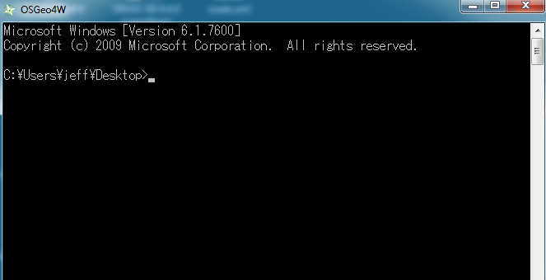
- CD (change directory) to the example17 directory.
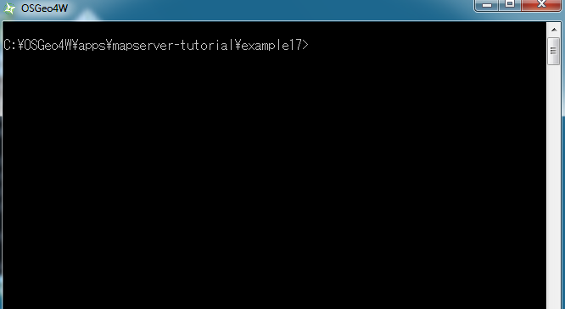
- Execute: shp2img -m example.map -o test.png -map_debug 3
(this should generate a 'test.png' map image, or display an error)

- Drag 'test.png' into your Web browser.
(if you have a blank image, open example17/example.map in a text editor and replace all 'STATUS OFF' values with 'STATUS ON' and retry shp2img)
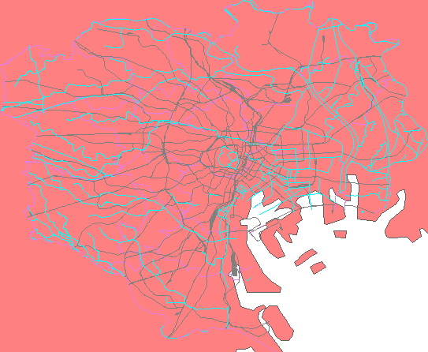
You should now see a map image of our local layers overlayed on top of the remote WFS server (continents) layer.

Using WCS Services with MapServer

About WCS
Another standard introduced by the Open Geospatial Consortium is the Web Coverage Service (WCS) specification, which shares raster features through a multidimensional range of properties. The raster data is shared as coverages, allowing the client to execute complex queries against the data.

MapServer has always been one of the early adopters of OGC standards. MapServer's OGC standard support is well documented at: http://www.mapserver.org/ogc/ The following section will discuss MapServer's WCS support. MapServer can act as a WCS server (serving raster coverages to other servers), but MapServer cannot act as a WCS client. Some relevant documents from MapServer are:

- MapServer WCS Server Howto: http://www.mapserver.org/ogc/wcs_server.html
- MapServer WCS Use Cases: http://www.mapserver.org/ogc/wcs_format.html

Exercise 18: Serving WCS Layers Through MapServer
In this exercise we will add a few mandatory parameters to our mapfile so that it can be served through the WCS standard.
Step1: Configure Your Mapfile

The mapfile used in this exercise is:
MAP
NAME "mapserver_tutorial_wcs_server"
IMAGETYPE PNG
EXTENT 138.6464391 35.0053821 141.5283462 37.0799579
SIZE 550 450

IMAGECOLOR 255 255 255
SHAPEPATH "../data"

FONTSET ../fonts/fonts.txt

UNITS dd

WEB
TEMPLATE 'example_template.html'
IMAGEPATH "C:\OSGeo4W/tmp/ms_tmp/"
IMAGEURL "/ms_tmp/"
MINSCALEDENOM 1000
MAXSCALEDENOM 70000
METADATA
"wcs_label" "MapServer Tutorial WCS Server"
"wcs_description" "Demonstration WCS service serving a single Landsat image of Tokyo (path:107 row:035)"
"wcs_onlineresource" "http://127.0.0.1/cgi-bin/mapserv.exe?MAP=C:\OSGeo4W/apps/mapserver-tutorial/example18.map"
END
END

PROJECTION
"init=epsg:4301"
END

LAYER
NAME "landsat"
METADATA
"wcs_label" "Landsat"
"wcs_rangeset_name" "Range 1"
"wcs_rangeset_label" "Range 1 Label"
END
DATA "tokyo-landsat-p107-r035.tif"
TYPE RASTER

STATUS ON
PROJECTION
"init=epsg:4301"
END
DUMP TRUE
END
END

The highlighed text shows the required parameters to serve data through the WCS standard with MapServer, and they are described next:

WCS_LABEL
This metadata must be set in the WEB object and in every layer that you want served through WCS. Use it to describe your data. All possible WMS metadata items are documented at: http://www.mapserver.org/ogc/wcs_server.html#reference-section

WCS_DESCRIPTION
This metadata must be set in the WEB object and can be used for a longer description of your WCS service.

WCS_ONLINERESOURCE
This metadata item must be set in the WEB object; it is the URL to your mapserv.exe executable, and in our example includes the full path to our mapfile. More information about this metadata item can be read at: http://www.mapserver.org/ogc/wms_server.html#more-about-the-online-resource-url

WCS_RANGESET_NAME
This metadata item must be set in each LAYER object, and can be used to describe the properties assigned to the coverage.

WCS_RANGESET_LABEL
This metadata item must be set in each LAYER object, and can be used to describe the properties assigned to the coverage.

PROJECTION
In order to serve data through any OGC standard, you must specify the projection that the data is in. Each layer must have a PROJECTION object, as well as a PROJECTION set at the MAP object level. Please read the MapServer documentation on the PROJECTION object: http://www.mapserver.org/mapfile/projection.html

DUMP TRUE
To serve the layer's data as a WCS coverage, you must set the DUMP TRUE parameter in your LAYER object.

Step2: Validate Your Server's Capabilities
Now that we have configured our mapfile for serving WCS, we must check that it is configured properly for the standard. We do this by using the onlineresource URL in a browser, and add the following to it: “&SERVICE=WCS&VERSION=1.0.0&REQUEST=GetCapabilities “. In our example, the full request is:

http://127.0.0.1/cgi-bin/mapserv.exe?MAP=C:/OSGeo4W/apps/mapserver-tutorial/example18/example.map&SERVICE=wcs&VERSION=1.0.0&REQUEST=GetCapabilities

Generally that request is referred to as the GetCapabilities request. If you execute it in a browser, you will be asked to save a file: rename this file so that it has a .xml extension (such as 'mapserv.xml'). Then open this file in a text editor. You should see a response from your WCS server, describing the layers available, such as:

<?xml version="1.0" encoding="ISO-8859-1" standalone="no"?>
<WCS_Capabilities version="1.0.0" updateSequence="0" xmlns="http://www.opengis.net/wcs" xmlns:xlink="http://www.w3.org/1999/xlink" xmlns:gml="http://www.opengis.net/gml" xmlns:xsi="http://www.w3.org/2001/XMLSchema-instance" xsi:schemaLocation="http://www.opengis.net/wcs http://schemas.opengis.net/wcs/1.0.0/wcsCapabilities.xsd">
<Service>
<description>Demonstration WCS service serving a single Landsat image of Tokyo (path:107 row:035)</description>
<name>MapServer WCS</name>
<label>MapServer Tutorial WCS Server</label>
<fees>NONE</fees>
<accessConstraints>
NONE

</accessConstraints>
</Service>
<Capability>
<Request>

<GetCapabilities>
<DCPType>
<HTTP>
<Get><OnlineResource xlink:type="simple" xlink:href="http://127.0.0.1/cgi-bin/mapserv.exe?MAP=C:\OSGeo4W/apps/mapserver-tutorial/example18.map&amp;"/></Get>
</HTTP>
</DCPType>
<DCPType>
<HTTP>
<Post><OnlineResource xlink:type="simple" xlink:href="http://127.0.0.1/cgi-bin/mapserv.exe?MAP=C:\OSGeo4W/apps/mapserver-tutorial/example18.map&amp;"/></Post>
</HTTP>
</DCPType>
</GetCapabilities>
<DescribeCoverage>
<DCPType>
<HTTP>
<Get><OnlineResource xlink:type="simple" xlink:href="http://127.0.0.1/cgi-bin/mapserv.exe?MAP=C:\OSGeo4W/apps/mapserver-tutorial/example18.map&amp;"/></Get>
</HTTP>
</DCPType>
<DCPType>
<HTTP>
<Post><OnlineResource xlink:type="simple" xlink:href="http://127.0.0.1/cgi-bin/mapserv.exe?MAP=C:\OSGeo4W/apps/mapserver-tutorial/example18.map&amp;"/></Post>
</HTTP>
</DCPType>
</DescribeCoverage>

<GetCoverage>
<DCPType>
<HTTP>
<Get><OnlineResource xlink:type="simple" xlink:href="http://127.0.0.1/cgi-bin/mapserv.exe?MAP=C:\OSGeo4W/apps/mapserver-tutorial/example18.map&amp;"/></Get>

</HTTP>
</DCPType>
<DCPType>
<HTTP>
<Post><OnlineResource xlink:type="simple" xlink:href="http://127.0.0.1/cgi-bin/mapserv.exe?MAP=C:\OSGeo4W/apps/mapserver-tutorial/example18.map&amp;"/></Post>
</HTTP>
</DCPType>
</GetCoverage>
</Request>
<Exception>
<Format>application/vnd.ogc.se_xml</Format>
</Exception>
</Capability>
<ContentMetadata>
<CoverageOfferingBrief>
<name>landsat</name>
<label>Landsat</label>
<lonLatEnvelope srsName="urn:ogc:def:crs:OGC:1.3:CRS84">
<gml:pos>138.646439071208 35.0053821042488</gml:pos>
<gml:pos>141.528346228667 37.0799578740914</gml:pos>
</lonLatEnvelope>
</CoverageOfferingBrief>
</ContentMetadata>
</WCS_Capabilities>

If you are going to add a WCS layer from a remote server, it is recommended that you look at the server's GetCapabilities document.
Step3: Execute a DescribeCoverage
Now that we have verified the service with a GetCapabilities command, we can check a coverage offered by our WCS service. We do this by using the onlineresource URL in a browser, and add the following to it: “&SERVICE=WCS&VERSION=1.0.0&REQUEST=DescribeCoverage&COVERAGE=landsat “. In our example, the full request is:

http://127.0.0.1/cgi-bin/mapserv.exe?MAP=C:/OSGeo4W/apps/mapserver-tutorial/example18/example.map&SERVICE=wcs&VERSION=1.0.0&REQUEST=DescribeCoverage&COVERAGE=landsat

You should see a response from your WCS server, describing the layers available, such as:

<?xml version="1.0" encoding="ISO-8859-1"?>
<CoverageDescription version="1.0.0" updateSequence="0" xmlns="http://www.opengis.net/wcs" xmlns:xlink="http://www.w3.org/1999/xlink" xmlns:gml="http://www.opengis.net/gml" xmlns:xsi="http://www.w3.org/2001/XMLSchema-instance" xsi:schemaLocation="http://www.opengis.net/wcs http://schemas.opengis.net/wcs/1.0.0/describeCoverage.xsd">
<CoverageOffering>
<name>landsat</name>
<label>Landsat</label>
<lonLatEnvelope srsName="urn:ogc:def:crs:OGC:1.3:CRS84">
<gml:pos>138.646439071208 35.0053821042488</gml:pos>
<gml:pos>141.528346228667 37.0799578740914</gml:pos>
</lonLatEnvelope>
<domainSet>
<spatialDomain>
<gml:Envelope srsName="EPSG:4326">
<gml:pos>138.646439071208 35.0053821042488</gml:pos>
<gml:pos>141.528346228667 37.0799578740914</gml:pos>
</gml:Envelope>
<gml:Envelope srsName="EPSG:4301">
<gml:pos>138.646439071208 35.0053821042488</gml:pos>
<gml:pos>141.528346228667 37.0799578740914</gml:pos>
</gml:Envelope>
<gml:RectifiedGrid dimension="2">
<gml:limits>

<gml:GridEnvelope>
<gml:low>0 0</gml:low>
<gml:high>9862 7099</gml:high>
</gml:GridEnvelope>
</gml:limits>

<gml:axisName>x</gml:axisName>
<gml:axisName>y</gml:axisName>
<gml:origin>
<gml:pos>138.646439071208 37.0799578740914</gml:pos>
</gml:origin>
<gml:offsetVector>0.000292193770400368 0</gml:offsetVector>
<gml:offsetVector>0 -0.000292193770400368</gml:offsetVector>
</gml:RectifiedGrid>
</spatialDomain>
</domainSet>
<rangeSet>
<RangeSet>
<name>Range 1</name>
<label>Range 1 Label</label>
</RangeSet>
</rangeSet>
<supportedCRSs>
<requestResponseCRSs>EPSG:4301</requestResponseCRSs>
<nativeCRSs>EPSG:4301</nativeCRSs>
</supportedCRSs>
<supportedFormats>
<formats>GTiff</formats>
</supportedFormats>
<supportedInterpolations default="nearest neighbor">
<interpolationMethod>nearest neighbor</interpolationMethod>
<interpolationMethod>bilinear</interpolationMethod>
</supportedInterpolations>
</CoverageOffering>
</CoverageDescription>
Step4: Try Your Service with a WCS Client
As MapServer cannot act as a WCS client, please check the list of compliant WCS products and choose your preferred client to test your service:
http://www.opengeospatial.org/resource/products/compliant

